|  |
| --- |
|  |

|  |  |  |  |
| --- | --- | --- | --- |
| **SR NO** | | **TOPIC** | **PAGE NO** |
| **1** | | **INTRODUCTION** |  |
|  | 1.1 | Introduction | 1 |
|  | 1.2 | History | 2 |
|  | 1.3 | 1.3.1 Introduction to taxation | 4 |
|  |  | 1.3.2 Types of taxes | 6 |
|  | 1.4 | 1.4.1 Meaning of GST | 8 |
|  |  | 1.4.2 Different types of GST taxes | 9 |
|  |  | 1.4.3 Taxes combined to form GST | 11 |
|  |  | 1.4.4 Implementation of GST | 12 |
|  |  | 1.4.5 Salient features of GST | 13 |
|  |  | 1.4.6 Need of GST model in India | 15 |
|  | 1.5 | 1.5.1 Impact of GST in Indian economy | 16 |
|  |  | 1.5.2 Advantages and Disadvantages of GST for Indian economy | 18 |
|  |  | 1.5.3 Challenges faced by Indian economy | 20 |
|  | 1.6 | 1.6.1 Impact of GST on restaurant | 22 |
|  |  | 1.6.2 Changes in restaurant industry | 23 |
|  |  | 1.6.3 Benefits and Drawbacks of GST on Restaurant | 25 |
|  |  | 1.6.4 Pre & Post GST mechanism of Restaurant | 28 |
|  |  | 1.6.5 Registration of GST | 31 |
|  | 1.7 | GST rate on restaurant services under composition and regular scheme | 36 |
|  | 1.8 | Service charge on restaurant food | 38 |
|  | 1.9 | Impact of GST on food consumers in restaurants | 40 |
|  | 1.10 | 1.10.1 Impact of GST on restaurant owners | 44 |
|  |  | 1.10.2 Comparison of pre and post-GST restaurant owner bill. | 46 |
| **2** | | **Research methodology** | 47 |
|  |  | 2.1 Objective of the study | 48 |
|  |  | 2.2 Scope of the study | 49 |
|  |  | 2.3 Limitation of the study | 50 |
|  |  | 2.4 Research hypothesis | 51 |
|  |  | 2.5 Significance of the study | 52 |
|  |  | 2.6 Data collection | 53 |
|  |  | 2.7 Data analysis technique | 54 |
| **3** | | **Literature review** | 57 |
| **4** | | **Data analysis, interpretation and presentation** | 62 |
| **5** | | **Conclusion and suggestion** |  |
|  | 5.1 | Findings | 78 |
|  | 5.2 | Suggestions | 79 |
|  | 5.3 | Conclusion | 80 |
|  |  | **Annexure** | 81 |
|  |  | **Webliography** | 84 |

|  |  |  |  |
| --- | --- | --- | --- |
| **Sr. No** | **Fig.No** | **TITLE** | **PAGE NO** |
| 1 | 5.1 | Gender Classification | 62 |
| 2 | 5.2 | Age Classification | 63 |
| 3 | 5.3 | Occupation Classification | 64 |
| 4 | 5.4 | Classification of Monthly Income | 65 |
| 5 | 5.5 | Tax Reform | 66 |
| 6 | 5.6 | GST rates on food and drinks | 67 |
| 7 | 5.7 | Percentage of satisfaction | 68 |
| 8 | 5.8 | GST as replacement for service tax and VAT | 69 |
| 9 | 5.9 | Eating Habits | 60 |
| 10 | 5.10 | Impact of GST | 71 |
| 11 | 5.11 | Awareness of tax components | 72 |
| 12 | 5.12 | Changes Post GST in menu | 73 |
| 13 | 5.13 | Result of GST | 74 |
| 14 | 5.14 | Changes in quality of food or services | 75 |
| 15 | 5.15 | Understanding New Tax Structure | 76 |
| 16 | 5.16 | Tipping Habits | 77 |

**1.1 INTRODUCTION**

The implementation of the GST is the most significant and ambitious indirect tax reform in India since Independence. Its goal is to impose a single, uniform national tax on all commodities and services throughout India. Numerous Central and State taxes have been replaced by GST, which has also increased the nation's market integration and added more producers to the tax system. Efficiency gains have a significant positive impact on both GDP and government revenue. In the long and complicated history of modern global taxes, it may be unusual for the Centre and the States to enact a new tax that applies to both goods and services.

GST is a tax on goods and services with extensive and ongoing set-off advantages all the way down to the retailer level. At each level, it is essentially a tax only on the value added, and a supplier is allowed to offset the GST paid on the acquisition of goods and services using a tax credit method. The final consumer of the good or service—the end-user—is responsible for paying the GST.

With the implementation of the GST, a continuous chain of set-off has been formed from the original producer's point and service provider's point up to the retailer's level, avoiding the burden of any cascading or pyramiding impacts of an indirect tax system. This sums up GST in its most basic form. Only the end customer is taxed under GST. As a result, production costs are decreased, and tax cascading (tax-on-tax) is prevented.

As was already said, the Indian indirect tax system had several drawbacks prior to the implementation of GST. Prior to the introduction of the GST, the States' sales tax system and the Central Excise Duty system had a tax-on-tax burden. Many of the Centre’s and States' indirect taxes have been incorporated into the GST. For set-off relief, it has incorporated taxes on both goods and services. Additionally, it has captured some value adds in the distribution industry. There is now an ongoing series of setoffs that would take care of all cascading impacts.

Services currently make up a substantial portion of India's tax base, although this potential has not yet been fully realised. In this scenario, the GST is appropriate because it includes practically all services for taxes purposes. The number of taxes has significantly decreased because of the major Central and State indirect taxes being incorporated into the GST, which would lower the operational costs of the nation's tax system. Costs associated with compliance will be significantly decreased by the nation-wide uniformity of tax rates and procedures.

**1.2 HISTORY OF GST**

In 2000, the Vajpayee administration formed an empowered committee led by West Bengal finance minister Asim Dasgupta to develop and discuss the GST concept. Following that, the Task Force on Fiscal Responsibility and Budget Management Act Implementation (Chairman: Vijay Kelkar) recommended that India eliminate all ineffective and anticompetitive taxes to reap the benefits of a single national tax and a comprehensive GST based on the VAT principle. In his budget speech for the fiscal year 2005-2006, P. Chidambaram, the then-Union Finance Minister, stated that a goods and services tax that includes both the Centre and the States should be applied to the entire production-distribution chain.

The idea of instituting a GST was first proposed here. In his budget address for the fiscal year 2006-2007, he proposed April 1, 2010, as the date for GST implementation. An Empowered Committee (EC) comprised of State Finance Ministers was to develop a roadmap for GST implementation in order to achieve this goal. The report's final version, "A Model and Roadmap for Goods and Services Tax in India," was published on April 30, 2008.

On November 10, 2009, the EC issued the First Discussion Paper on Goods and Services Tax in India to solicit input from business, trade organisations, and the general public after receiving comments on the report from the Government of India and concerned officials of the State Governments and considering their recommendations. The Constitution (115th Amendment) Bill was introduced in the Lok Sabha on March 22, 2011, in order to make the GST operational and give the Centre and States the ability to enact laws for GST levying. The Bill, however, became ineffective following the dissolution of the 15th Lok Sabha.

On December 19th, 2014, the Lok Sabha received the Constitution (122nd Amendment) Bill, 2014, which addressed several GST-related issues. It's worth noting that the implementation of GST 2 necessitated a set of restrictions as well as an endogenous tax on the "supply of goods and services," whether levied by the Central Government or a State Government. While states may tax the sale of goods, the Centre may tax both services and goods up until the point of manufacture. A constitutional amendment was required because the GST regime requires the Central and State Governments to levy taxes on goods and services at the same time.

On May 6, 2015, the Lok Sabha passed the Constitution (122nd Amendment) Bill, 2014. The Rajya Sabha passed the bill with nine amendments on August 3, 2016. On August 8, 2016, the Lok Sabha approved the amended Bill. On September 8, 2016, it was delivered to the President for his assent after receiving approval from half of the states. As a result, the enactment procedure was completed, and the way was cleared for the GST rollout. In 2017, the Lok Sabha passed four additional GST Bills, which were then approved by the Cabinet. The new tax system went into effect on July 1st, 2017, after Rajya Sabha approved four additional GST Bills.

Governments impose taxes on its citizens to raise money for implementing initiatives that would strengthen the nation's economy and increase the standard of living for its citizens.

The Constitution of India, which grants the Central and State governments the ability to impose taxes, is the source of the government's right to do so in India. In India, a supporting law must be passed by the State Legislature or the Parliament to support any taxes that are imposed.

On many levels, including national development, infrastructure improvement, societal advancement, and even national welfare programmes, tax payment is advantageous.

**1.3.1 INTRODUCTION TO TAXATION**

* WHAT IS TAX?

Taxes are mandatory payment imposed by the government on the general public for the benefit of the society. The governments primary source of revenue is taxes.

Taxation accounts for up to 90%of the government’s total revenue. Taxation is the cost of living in a civilised society.

* WHY ARE TAXES IMPLIED?

Because taxes are the government's main source of revenue, they are levied against the people.

The government uses tax revenue to pay for things like health care facilities, road and dam construction, educational facility maintenance, and defence-related purposes.

The following are the reasons for taxation:

1. To raise the standard of living for all citizens of the country.

2. To close the wealth gap by raising taxes on the wealthy and providing aid to the poor.

3. To protect the country from unwelcome elements such as terrorists and other nations that wish to wreak havoc in our country.

4. Taxation is a responsibility that every citizen of our country must fulfil.

* IN INDIA, WHO SHOULD PAY TAX?

Every individual in India who earns more than a certain amount of money is required to pay income tax. The government determines the limit or minimum amount of income above which an individual is required to pay tax, and it is subject to change from time to time. The basic exemption limit for individuals under 60 years of age is Rs. 2.5 lakhs for the fiscal year 2021-2022 (assessment year 2022-2023), which means that individuals earning income above this limit must pay income tax. The exemption limit for senior citizens (between 60 and 80 years of age) is Rs. 3 lakhs, and the exemption limit for super senior citizens (over 80 years of age) is Rs. 5 lakhs. However, if an individual receives income from inputs other than salary, such as rent, savings interest, capital gains from the sale of assets, or any other source, he or she may be required to pay tax even if the total income is less than the exemption limit.

The following organisations are also required to pay direct taxes:

• Artificial Juridical Persons

• Companies

• Corporate Firms

• Local Authorities

• Association of Individuals

• Body of Individuals

**1.3.2 TYPES OF TAXES**

* DIRECT TAX

Direct tax is a type of tax in which the burden of the tax cannot be transferred from one taxpayer to another or to a third party. The direct taxes are followed by the following:

1. Corporate tax
2. Double tax avoidance treaty
3. Tax incentives
4. Fringe benefit tax
5. Personal income tax
6. Capital gain tax.

* INDIRECT TAX

Direct tax and indirect tax are two distinct taxes. In an indirect tax, the tax burden is transferred from one taxpayer to another. Here are a few prominent examples of indirect taxes: -

1. Value added tax (VAT)
2. sales tax
3. services value tax
4. custom duty
5. excise tax
6. Goods and services tax

* LOCAL TAXES

These taxes, which include the doctor tax and the entry tax, are those that the government imposes on entities of products.

* INCOME TAX

Income tax is a type of tax in which an individual or an entire company is taxed or subject to an obligation based on their income in the case of an individual and their profit produced during the financial year in the case of a business. Depending on one's income, income tax may differ from one person to the next.

* CONSUMPTION TAX

A tax based on an individual's consumption is known as a consumption tax, and it differs from an income tax in this regard. Sales tax is an example of a consumption tax; income tax is based on income, but consumption tax is based on the use of goods and services. Because every individual will be required to pay the same amount of tax on goods and services, consumption taxes are inherently regressive. Let's use the purchase of a 10-rupee pen as an example; Shahrukh Khan will pay the same price as a regular person like me. In a consumption tax, a consumer's wealth has no bearing on the cost of the goods and services.

**1.4.1 MEANING OF GOODS AND SERVICE TAX (GST)**

GST is defined as any tax on the supply of goods, services, or both, except for taxes on the supply of alcohol for human consumption, under clause 366 (12A) of the constitution bill. Furthermore, the Bill's Article 366 (26A) defines services as anything besides goods. Thus, it is possible to define GST as a complete national tax imposed on the production, sale, and consumption of goods and services. There are three different types of GST: IGST for interstate transactions, SGST for state governments to collect, and CGST for the central government to collect. GST will eliminate the effects of cascading taxes. Tax on tax, or the "cascading tax impact," indicates that a consumer must pay tax on tax.

**PROFILE OF THE STUDY**

One of the most significant tax innovations in Indian tax history is the GST. The Indian economy has been severely impacted in practically all areas. Depending on a variety of variables, including the type of establishments and the location of the restaurant or food service provider, the Goods and Services Tax paid on food services in India can range from 5%, 12%, or 18%. While the fundamental service charges levied by restaurants are not included in the GST, the basic implementation of the GST on the food services replaced the VAT and the service tax system. The fact that alcoholic beverages continue to be subject to VAT, which is only a state-level tax, is also noteworthy. As a result, restaurants that serve both food and alcoholic beverages will typically have a different tax rate, with the GST very much applying to food and non-alcoholic beverages while the VAT will still be charged on various alcoholic beverages being served.

**1.4.2 DIFFERENT TYPES OF GST TAXES**

**Central Goods and Services Tax, or CGST**, is a tax that is imposed by the national government.

The CGST is only applicable within the state, the money collected from taxes goes to the federal government, and it makes no difference if the limit does not go over 40 lakhs. The Central Goods and Services Tax (CGST), like State GST, is a tax levied under the GST regime that is levied on intrastate (within the same state) transactions. The CGST Act governs the CGST. The Central Government oversees collecting the CGST revenue. As previously stated, if a trader from West Bengal sells goods worth Rs.5,000 to a customer in West Bengal, the GST applicable on the transaction will be a combination of CGST and SGST. If the GST rate charged is 18%, it will be split evenly into 9% CGST and 9% SGST.

**State goods and services tax, or SGST**, is a tax imposed by the state government. The state government only receives tax money from SGST if the limit surpasses 40 lakhs within a single state. The State Goods and Services Tax (SGST) is a tax levied under the GST regime on intrastate (within the same state) transactions. Both State GST and Central GST are levied on intrastate supplies of goods and/or services. The State GST or SGST, on the other hand, is levied by the state on goods and/or services purchased or sold within the state. The SGST Act regulates it. The revenue generated by SGST is solely claimed by the state government. For example, if a West Bengal trader sells goods worth Rs.5,000 to a West Bengal customer, the GST applicable on the transaction will be a combination of CGST and SGST. If the GST rate charged is 18%, it will be split evenly into 9% CGST and 9% SGST. In this case, the total amount charged by the trader will be Rs.5,900. The revenue generated by GST under the heading of SGST, i.e., Rs.450, will be distributed to the West Bengal state government in the form of SGST.

**The Integrated Goods and Services Tax, or IGST,** is a tax levied jointly by the federal and state governments. Applies to imports and supplies manufactured in the state. Each state and federal government receives a portion of the tax revenue. The Integrated Goods and Services Tax (IGST) is a GST tax levied on interstate (between two states) supplies of goods and/or services, as well as imports and exports. The IGST Act governs the IGST. The Central Government oversees collecting IGST taxes. The collected taxes are divided among the various states by the Central Government.

For example, if a trader from Karnataka sells goods worth Rs.5,000 to a customer in Chennai, IGST will apply because the transaction is interstate. If the goods are subject to an 18% GST, the trader will charge Rs.5,900 for them. The IGST collected amounts to Rs.900, which will be paid to the Central Government.

**Union Territory Goods and Services Tax, or UGST.** Union Territory Goods and Services Tax (UGST) is a type of tax levied on the supply of goods and services in the Union Territories of India. It is a sub-type of Goods and Services Tax (GST) which was implemented in India on 1st July 2017.Under the GST regime, the GST is divided into two components - the Central GST (CGST) and the State GST (SGST). However, in the case of Union Territories, there are no separate state governments. Hence, the UTGST was introduced to replace the SGST. The UGST is applicable in the Union Territories of India, which include Andaman and Nicobar Islands, Chandigarh, Dadra and Nagar Haveli and Daman and Diu, Lakshadweep and Puducherry. The UGST rate is usually the same as the SGST rate in the corresponding State. The proceeds from the UGST are collected by the Central Government and distributed to the respective Union Territory administrations. The UGST is a significant revenue source for the Union Territory Governments to fund their developmental activities.

**1.4.3 TAXES WHICH ARE COMBINED TO FORM GOODS AND SERVICE TAX**

**Taxes under SGST**

* Vat/ sales tax
* Luxury tax
* Entertainment tax
* Taxes on gambling, lotteries and wagering.

**Taxes under CGST**

* Service tax
* Additional excise duty
* Central excise duty
* Additional custom duty
* Surcharges

**Taxes under CGST which does subsume comes under GST.**

* Custom duty
* Excise on tobacco and petrol goods
* Specific cesses basic
* Central sales tax on liquor for drinking purposes

**Taxes under SGST which does subsume come under GST.**

* Alcoholic liquor does come under SGST.
* Taxes on entertainment do not come under SGST because they are collected by the panchayat or the municipality or by some local government bodies.
* Stamp duty on transfer of immovable property
* Tax on sale of electricity or tax on consumption

**1.4.4 IMPLEMENTATION OF GST IN INDIA**

According to a World Bank report, the Narendra Modi government's goods, and services tax (GST), which went into effect on July 1, 2017, is one of the most complex, with the second highest tax rate in the world among a sample of 115 countries with a similar indirect tax system. In India, there are five tax slabs: 0%, 5%, 12%, 18%, and 28%. Furthermore, certain sales are exempt, and exports are zero-rated, allowing exporters to claim a tax refund on input taxes. Gold is taxed at 3% and precious stones at 0.25% separately, while alcohol, petroleum products, real estate stamp duties, and electricity duties are exempt from the GST and continue to be taxed at state-specific rates. There are 49 countries with a single GST slab, 28 with two slabs, and only five with four non-zero slabs, including India. Italy, Luxembourg, Pakistan, and Ghana are a few examples of countries with four or more GST slabs. As a result, India has the most diverse GST slabs in the world. Arun Jaitley, the finance minister, has promised to combine the 12% and 18% GST slabs once tax compliance and revenue buoyancy improve. The GST Council, the federal indirect tax body, reduced the number of items subject to the 28% tax slab from 228 to 50 at its November meeting in Guwahati last year. According to the World Bank's bi-annual India Development Update report, the implementation of GST was accompanied by disruptions in state administrations in the days that followed. This included a lack of clarity regarding the repeal of local taxes, such as in Tamil Nadu, where the state government devolved an entertainment tax to local governments to be imposed alongside a 28% GST. To maintain revenue collections, Maharashtra increased motor vehicle tax to compensate for GST losses.

According to the World Bank, firms have reported increased administrative tax compliance burdens and working capital lock-up because of slow tax refund processing. "High compliance costs are also emerging as a result of the prevalence of multiple tax rates, which necessitates categorising inputs and outputs according to the applicable tax rate. Firms must match invoices between outputs and inputs in order to qualify for full input tax credit, which raises compliance costs even higher "It was also included. While international experience suggests that the adjustment process can have a long-term impact on economic activity, the World Bank believes that the benefits of the GST will outweigh the costs in the long run.

**1.4.5 SALIENT FEATURES OF GST**

1. The tax is imposed in accordance with the current notion on the production, sale, and provision of products and services. GST, however, would apply to the delivery of goods or services.
2. The GST will have a dual impact because it will be levied simultaneously on a common tax base by the Centre and the States. The Central GST (CGST), which the Centre will levy on intrastate supplies of goods and/or services, and the State GST (SGST), which the States will levy, on interstate supplies, are two different types of GST.
3. All products will be subject to the GST, apart from alcoholic beverages intended for human use and five petroleum products: petroleum crude, motor spirit (petrol), high-speed diesel, natural gas, and aviation turbine fuel. Apart from a few to be mentioned, it would apply to all services.
4. Tobacco and tobacco-related products will be subject to the GST, and the government can impose central excise taxes on them.
5. The GST will replace the following taxes, which are currently assessed and collected by the Centre:

• Excise Duty at the Central Level

• Excise Duties (Medicinal and Toilet Preparations)

• Additional Excise Duties (Goods of Special Importance)

• Additional Excise Duties (Textiles and Textile Products)

• Additional Customs Duties (commonly known as CVD)

• Customs Special Additional Duty (SAD)

• Tax on Services

1. The GST includes the following state taxes:

• Local VAT

• Central State Tax

• Luxury Tax

• Entry Tax on Lien of Octroi (ETILOO)

• Advertisement Tax

• Purchase Tax

• Lotteries, Betting, and Gambling Tax

• State cesses and surcharges relating to the supply of goods and services.

* ETILOO is a small tax that is difficult to implement and has a significant negative impact on the economy. It causes a schism in the Indian common market and acts as a tax on imports from the rest of the country into a local or municipal territory.

1. The Centre would impose and collect an Integrated GST (IGST) on the exchange of goods and services between States. Guarantee that the SGST share of IGST is transferred to the destination State where the products or services are ultimately consumed, the accounts would be settled periodically between the Centre and the States.
2. The taxpayers shall be permitted to claim an input tax credit for taxes paid on inputs and apply it toward the payment of output taxes. However, neither a CGST input tax credit nor an SGST payment may be made using a CGST input tax credit. It would be possible to pay IGST, CGST, and SGST in that sequence using the credit from IGST.
3. Under the GST regime, commodities will be categorised using the Harmonized System of Nomenclature (HSN) code. Taxpayers with a turnover of more than Rs. 1.5 crore but less than Rs. 5 crores must use a 2-digit number, while those with a turnover of more than Rs. 5 crores must use a 4-digit code.
4. Exports are to be considered zero-rated supplies. While there is no tax due on items exported, exporters may claim a credit for any applicable input taxes.
5. The import of goods and services would be considered as inter-State supplies and be taxable to the IGST in addition to the relevant customs charges.

**1.4.6 NEED OF GST MODEL IN INDIA**

The following are some of the reasons why GST should be implemented.

* The current tax system allows for a variety of taxes; however, the introduction of GST is likely to make it unique.
* Many areas of Services are tax-free. They will also be covered after the implementation of GST.
* GST may aid in the development of a common national market by reducing the confusion caused by the current complex tax structure.
* Excise, VAT, and CST all have tax cascading effects. As a result, there will be double taxation. All current taxes will be replaced by GST.
* GST will result in the availability of credit for throughway purchases as well as a reduction in obedience requirements.
* GST will do more than just shift the tax burden from one sector or group of the economy to another.
* Achieves tax uniformity across the territory, regardless of place of manufacture or distribution; and provides greater tax certainty and transparency.
* Ensures tax compliance throughout the country.
* To some extent, GST will prevent double taxation.
* GST implementation ensures that India provides a tax system that is nearly identical to the rest of the world where GST is implemented.
* GST will also improve the international cost competitiveness of various indigenous Goods and Services.
* GST will provide an unbiased tax structure that is unaffected by business processes or geographical locations in India.
* If the GST is implemented correctly, it will have many positive effects for stakeholders and will result in a more favourable tax environment.

**1.5.1 IMPACT OF GST ON INDIAN ECONOMY**

To eliminate the cascading effect of taxes and to provide for a common national market for goods and services, the Government of India proposed amendments to introduce the goods and services tax, which would confer concurrent taxing powers on the union as well as states, including union territories, with legislature to make laws levying goods and services tax on all transactions. GST is an indirect tax that was implemented in India on July 1, 2017, and was applicable throughout the country, replacing multiple cascading taxes levied by both the central and state governments. A GST Council governs the GST.

GST applies to goods and services at the following rates: 0%, 5%, 12%, 18%, and 28%, with a special rate of 0.25% on rough, precious, and semi-precious stones and 3% on gold. Furthermore, a 15% cess or other rates on top of the 28% Aerated drinks, luxury cars, and tobacco products are all subject to GST. Expert viewed it as biggest tax reform in India founded on the notion of "one nation, one market, one tax”. The implementation of GST has transformed India into a unified market of 1.3 billion people. The rollout raises the prospect of India's fiscal reform programme regaining momentum and broadening the country's economy. The goal of implementing GST in the country's 29 states and 7 union territories is to provide a win-win situation for all citizens. The entire taxation base will be shared between the central assessment mechanism and the states, which will be able to collect taxes on economic activities taking place in Indian territorial waters. The centre made significant concessions to bring states, including the defiant ones, to the ninth GST council meeting. The following administrative decisions will be made. The state will administer 90% of the tax players, including service providers with annual turnovers of up to Rs 1.5 crore, with scrutiny and audit powers, while the Centre will control the remaining 10%. Taxpayers with a turnover above that threshold, including those who pay integrated 9 interstate imports) GST, will be equally split between the centre and the states, resulting in a significant shift in the taxpayer base from the centre to the states.

There is a silver lining to the entire situation. The unorganised sector, which benefits from a cost advantage equal to the taxation rate, may be included in the GST bill. This will bring many unorganised players in fields such as electrical, paints, hardware, and so on into the tax net. It is simpler said than done. It will take a lot of meticulous planning to bring the unorganised sector under the purview of the GST reform. For one thing, it will broaden the tax base, and for another, it will benefit organised players who are currently losing revenue to the unorganised sector. There are still many uncharted territories that need to be explored through parliamentary debates in the sessions. To the individual and different companies, the accumulation of both central and state taxes will become one, both components will raise prices on manufacturing costs, and the individual will benefit from lower prices in the process, which will subsequently lead to an increase in consumption, thereby benefiting companies. The Congress party is already opposed to the 1% tax. The GS Tax rate is expected to be around 5-28%, which is a tax neutral rate. This tax rate is unlikely to generate any additional tax revenue for the government. The GST rate will benefit the various manufacturing sectors, where the tax rate is currently around 24%.

**1.5.2 ADVANTAGES & DISADVANGES OF GST FOR INDIAN ECONOMY**

ADVANTAGES**:**

GST benefits the economy. Government, consumers, and industry stakeholders all gain from it. GST aids in lowering the cost of goods and services. GST aids in the simplification of the tax code. The tax system encourages multinational corporations to our nation when it is made simpler.

1. One nation, one tax: The GST aims to remove economic barriers and simplify the taxation system to draw more MNCs to the Indian market.
2. Exports from India are zero rated: Since there is no GST applied to exports, this makes Indian goods more competitive on the world market and boosts the country's economy.
3. Taxpayer-friendly: The main goal of the GST is to simplify and remove obstacles that prevent taxpayers from paying their GST.
4. GST is based on IT: GST is completed online, which takes less time than manually filing taxes.
5. Support for economic growth: GST helps to increase manufacturing and exports, creating more jobs and boosting the Indian economy.
6. Check post removal: The removal of check posts at state borders is made possible by e-billing. Raw materials and finished goods are now moving freely and quickly.
7. Support for made in India products: The GST has given made in India products a boost by increasing the competitiveness of the country's goods and services both domestically and abroad.

DISADVANTAGES:

The disadvantages of the goods and services tax in India are as follows:

1. Transition proved difficult: When businesses switched to the new tax rate, it caused them many problems, which prompted the GST Council to relax its rules.
2. Software modification: Marketers must switch their accounting from ESP to GST software. The cost increased as a result of the purchase of new software.
3. Various tax rates: The GST has five tax slabs with rates of 0%, 5%, 12%, 18%, and 28%.
4. Registration in multiple states: Businesses are now required to file GST returns in each state in which they do business or operate.
5. Need for a professional: The GST makes it necessary for small businesses and newly formed businesses to hire professionals to handle GST.
6. Increasing operational costs: Hiring professionals to handle GST compliance results in an increase in the company's operating expenses.
7. Computerized GST: GST must be completed online with a computer's assistance, but some businesses do not have computers in their small shops and many people are not familiar with how computers operate, which causes many issues.

**1.5.3 CHALLENGES FACED BY INDIAN ECONOMY**

The Indian GST model, which is based on the Canadian GST model, would have been successful in our country if we had not been a diverse country; however, it has faced numerous failures and challenges in its implementation.

The fundamental belief on which GST is based, namely that one nation, one tax, cannot be implemented in a country like India. Prior to the introduction of GST, there were 32 taxes, including 29 state VAT taxes, one sales tax, one excise tax, and one service tax. However, the tax figure has not decreased significantly since the implementation of GST. We now have 31 taxes, including 29 SGST taxes, one CGST, and one IGST, which is an intricate tax structure that contradicts the country's basic approach of a single tax.

Also, according to the Constitutional Provisions and Supreme Court Decisions on GST in India, the 101 amendments to the constitution, Article 246 a state that parliament and states can levy taxes on the supply of goods and services, implying that not parliament but states can have their own GST, which contradicts the one tax regime.

According to Article 279 A of the constitution, the GST council has only advisory powers. As a result, it is up to state governments to put its ideas into action. The state government levies its own GST in this manner, distorting the country's entire GST system. On November 11, 2016, nine Supreme Court of India judges issued a decision in the entry tax case, ruling that every state has the same tax-levying authority as parliament. As a result, it gives states the authority to levy their own GST.

The GST system is completely reliant on online tax submission, which overburdens the Ministry of Corporate Affairs' online system, and the existing online infrastructure is not very stable, so the problem of hanging and website crashes occurs frequently, making tax filing more difficult than before.

Due to the implementation of the current GST system in the country, it also increases the problem of tax evasion, which results in huge losses in the country's economic condition due to the following provision existing in the Bill, which states that business entities with an annual turnover less than Rs. 20 lakhs are exempt from GST registration. The above provision in the bill is the biggest loophole that can exacerbate the problem of tax evasion, as illustrated by a simple example- If a businessman owns a firm or company with an annual turnover of 80 lakhs and falls under the GST taxpaying category, but instead of paying taxes, he divides his business into four firms of 20-20 lakhs and makes his wife, son, daughter, and himself directors of the four firms and by dividing the business into four parts with an annual turnover of rupees 20 lakhs, he is exempt from paying GST.

Originally, these four firms were only in the papers, and he saves his firm, which has an annual turnover of 80 lakh rupees to pay GST, and this is how people will do tax evasion in various forms, resulting in massive economic loss to the government.

**1.6.1 IMPACT OF GST ON RESTAURANT BUSINESS**

WHY RESTAURANT INDUSTRY ABSOLUTELY NEEDS GST?

Currently, the food service industry bears various taxes at every stage, from purchasing raw materials to selling finished products. Secondly, the multiple taxes collected from the customer on the final invoice are a major deterrent to the customer and play an important role in the deterrent.

Multi-tiered indirect taxes at central and state levels, as well as additional excise and customs duties, pose serious problems for the smooth functioning of the company.

Frequent changes in legislation and the multiple registrations required to start a new restaurant operation can be confusing, especially for first-time restaurant owners. and often cause confusion.

This is the main reason why most restaurants do not have proper licenses and often operate without proper legal process.

The new GST bill promises to:

* Eliminate control cascades.
* Unified Law and Unified Tariff
* Consistency and certainty in laws and their implementation
* Simplify compliance.

Registering for GST is also a straightforward process compared to the current scenario. The government has also committed to providing technical assistance to businesses to comply with the GST regime. The government has committed to implementation and post-implementation assistance.

Business transparency

All procurement and expenses are uploaded for greater business transparency. Total profit is calculated automatically. Restaurants can also file sales tax returns.

**1.6.2CHANGES IN RESTURANT INDUSTRY AFTER IMPLEMENTATION OF GST**

Restaurant customers saw a reduction in their bill following the implementation of GST, as the restaurant GST rate replaced multiple taxes and cesses, including VAT, Service Tax, and Krishi Kalyan cess, to name a few.

Customers noticed a decrease in the effective tax on restaurant bills following the implementation of GST. The cost savings for those who eat out, on the other hand, were found to be marginal at best. However, the service charge is unaffected by GST and is still levied by the restaurant.

The Input Tax Credit, or ITC, was expected to increase working capital availability for restaurant owners following the implementation of GST. In contrast, the implementation of GST resulted in the abolition of the Input Tax Credit, or ITC. As a result, they couldn't claim the GST they paid on raw materials and rent.

Following that, changes were made to reduce restaurant owners' ITC benefit. However, current GST rules limit this ITC benefit to restaurants and eateries that charge 18% GST on food services, while restaurants and eateries that charge 5% GST on food services do not receive ITC benefits.

As shown in the table above, food GST rate items such as vegetables, fruits, meat, and so on are GST-free, implying that most fresh and frozen products are GST-free. GST rates are only applicable to packaged foods in containers bearing a trademark/brand name. Currently, no more than 18% GST is levied on food or food services, and no food items are taxed at 28%. As a result of the GST implementation on food items, no significant price changes have been reported.

The popular "buy one, get one free" promotional schemes have also been impacted by GST. Freebies are intended to increase sales by various pre-packaged goods and food service companies. However, with the implementation of GST on July 1st, most offers were gradually phased out. Companies must now investigate alternative strategies such as product giveaways and discounts.

Food service conglomerates such as Jubilant Food Works, which operates the Domino's pizza chain, and Pizza Hut by Yum restaurants have also dropped buy one get one free deal from their promotional lists in favour of discounts (August 01,2017).

According to tax experts, a company that provides something for free must pay GST on it, and thus the regulation may be extended to the pharmaceutical industry as well.

According to GST laws, whenever a free item is sold, the GiST on the transactional value must be paid. This suggests that businesses may prefer to avoid predefined discounts and price cuts in order to avoid confusion about GST charges on freebies and uncertainty about input credit. Because of the new tax rules, small vendors and restaurants have distanced themselves from online delivery start-ups.

Companies must strive to deduct tax collected at supply (ICS) after they build payments made to restaurants or vendors utilising their platform under GST laws. This may discourage online adaptation of smaller restaurants with lower sales. Vendors will receive their payment after a 2% TCS (1% cache of Central GST and State GST), causing a disruption in the supply of working capital.

Restaurants will be able to claim input tax credits and receive refunds for ICS under GST. However, while the refund is being processed, the sum of the restaurants' working capital remains frozen.

Aggregator models used by online food service companies are best suited to smaller restaurants, vendors, and businesses, according to TCS, who also stated that TCS would hit methods of onboarding more and more restaurants.

Businesses that fall below the GST target level will be required to register with the GST network solely for the purpose of using e-commerce services. The use of online delivery by restaurants also removes the composition theme offer GST' filling. Restaurants with less than R$75 lakh in turnover are permitted to use a simplified GST composition theme and are not required to do separate invoicing.

**1.6.3 BENEFITS & DRAWBACKS OF GST ON RESTAURANT INDUSTRY**

Although the implementation of the GST bill will result in overall good news for the restaurant industry, it will not result in all gains. Previously, there was concern about the impact of the GST bill on QSRs and Cloud-kitchens, as they were all expected to be taxed at the same rate as restaurants. However, the new GST rate structure appears to benefit small restaurants and QSRs while harming 5-star restaurants and hotels.

Benefits

On Restaurants- Non-AC restaurants will be charged 12%, while AC restaurants will be charged 18%. A whopping 28% Luxury Tax will be levied on 5-star restaurants. Restaurants with a turnover of less than 50 lakh INR can breathe a sigh of relief, as they will be subject to a 5% GST rate. Bakeries are likely to benefit the most from the GST because the current VAT structure ranges from 26.5% to 39%. The lower overall cost would be a welcome relief for both the bakers and the customers.

* On Food Served- The food served in restaurants will be exempt from the dual taxation. Currently, the effective tax (which includes a 6% service tax and a 14.5% VAT) is 20.5%.
* Capital Goods Procurement- Currently, capital goods are purchased at a 14.5% VAT. The GST would be levied at 18%, causing costs to rise. This paints a bleak picture for new restaurants and food businesses that would be required to purchase Kitchen Equipment and other Capital Goods.
* On the Purchase of Raw Materials- The GST would have no effect on the raw materials and food costs of restaurants because agricultural products purchased directly from the farm were exempt from VAT and would remain so under the GST. The semi-purchased food was previously charged at 5% VAT and will remain at 5% GST.
* Operational Ease: A single nation with a one tax policy can help to bring the GST regime into line with the rest of the globe. With the elimination of various taxes and cesses, the introduction of GST will be the only charge that hotels must account for. This implies fewer procedural steps and more opportunities to streamline the taxation process.
* Tax reductions on food bills of approximately 9.5% can play an important role in luring additional consumers to eateries.
* Small-scale restaurant owners will benefit from a minimum tax block of 5-12% or no tax, depending on annual turnover.
* The new GSI scheme has the potential to increase government revenue, reduce corruption, and lower restaurant business prices.
* Saving time and improving quality: The removal of several entries from the accounts book in the name of various taxes allows for speedier transaction processing. This will also assist the consumer in receiving faster and fresher orders with room reservations made on every breezy process.

Drawbacks

On Five-Star Restaurants and Hotels- A whopping 28% Luxury Tax would be levied on high-end restaurants and five-star properties. This is a major setback for posh restaurants, as customers are likely to avoid eating at such establishments.

* Aerated Drinks- Aerated drinks have been assigned the highest GST slab, 28%. Currently, the effective tax cost ranges from 20.5% to 26% (VAT of 14.5% to 20%, plus the Service Tax).
* On Complimentary Offers- Now, complimentary offers are exempt from VAT. GST may be levied, raising the costs.
* On Liquor- Liquor is primarily imported from outside the country and is subject to state taxation and excise. As a result, liquor is exempt from GST. The state-specific VAT and Excise Duty would remain in effect, and the current Tax rate could be maintained. The price of liquor is likely to rise as a result of the GST.
* **Update**: According to the new GST rates announced by Finance Minister Arun Jaitley, both AC and non-AC restaurants will be charged 5% GST.
* Asian Market Competition: India is currently a major global competitor in the hotel and tourism industries. Because of improved services, better opportunities and options, and lower costs, India is becoming the most popular destination in Asian markets. To achieve equality, India's GST rates must compete with those of its Asian counterparts; however, there appears to be a significant gap, as shown below:
* Singapore (7%).
* Malaysia (6%).
* China = 11%
* Japan = 8%

The large disparity appears sarcastically at our service providers and provides the competition with an unfair edge. This alone is enough to make a potential tourist reconsider their travel plans.

The answer is not policy execution, but rather correct policy implementation, which solves all problems. Certain issues, such as excluding alcoholic beverages from GST preview, must be addressed sooner rather than later to remove additional burdens placed on the hotel industry.

**1.6.4 PRE- GST MECHANISM OF RESTAURANT INDUSTRY**

The Value Added Tax (VAT) system was used in every area of the economy prior to the introduction of the GST. Value Added Tax (VAT) is assessed on goods that are sold to you in an enhanced state, meaning that they have had value added to them before being sold. At various points during their manufacture, distribution, and sale, one must pay VAT on goods and services. In restaurants, packed items like food and alcoholic beverages in bottles are exempt from the VAT law. However, it applies to food and beverages that have been prepared in restaurant kitchens. Even within states, VAT varies depending on the type of product. It varies from state to state and even within the states. It could range from 5 to 20.

* On cooked foods and snacks offered by a restaurant, VAT is applicable at a rate of 5%.
* Cold drinks are subject to a 20% tax, while other non-food items are subject to a 14% tax.
* In addition, entry tax of 1% is due on all basic and incidental goods used in the production of cooked food.
* Outside caterers are also required to pay a 10% luxury tax under the LEAT Act, with the sale price deducted. This tax is subject to proper submission under the MPVAT Act, from which hospitals and educational institutions are exempt.
* The MP VAT Act imposes a 5% tax on the sale of alcoholic beverages to consumers.

In addition to the Swachh India cess of 0.5%, service tax is paid at a rate of 14%, making the total for us 14.5%. Along with Krishi Kalyan 15% of the service tax would be created overall with a cess of 0.5% starting on June 1, 2016. Ideally, service tax should only be required on the first 400th of the total bill, which is the cost of providing high-quality service, rather than on the remaining 60 minutes, which are primarily made up of the client's requested food and beverages. This suggests that the service tax is only liable for the first 400th of the total bill and not the entire amount. As a result, the service tax applicable to the entire bill is 5.8% (up from 6% as of June 1).

**BILLING STRUCTURE OF RESTAURANT PRE GST**

If a business chooses the composition money at 3% of its cooked food manufacturing turnover without the benefit of input tax rebates. This dealer has a yearly turnover of up to Rs. 1 crore. Dealers in composite materials are not eligible for an input tax credit.

**1.6.4 POST -GST MECHANISM OF RESTAURANT INDUSTRY**

This new tax structure separates the product into five groups: those that are tax-exempt, 5%, 12%, 18%, and 28%. Prior to the GST enrolment, dining at a restaurant was significantly easier. We usually pay the bill there, eat our meal, and then depart. We were then required to pay a service fee, service tax, and value-added tax (VAT). However, due to a lack of information regarding GST, restaurant proprietors could deceive any clients into paying more. Here are some things that customers need to learn in order to lead more intelligently.

First off, the fee charged as a service charge is not a tax. The restaurants impose service fees on their own initiative; it is not mandated by the government. However, customers are not required to pay if they choose not to. Whether the customer chooses to pay the fee or not is entirely up to them. A restaurant may be sued in a consumer court if it forces a customer to pay a service fee.

You must pay service tax and value added tax, which together make up your tax burden. Both taxes have been absorbed by and replaced by the GST. Tax of 12% must be paid when eating in non-AC restaurants. Both the central and state portions of the 12% GST make up this total. Local delivery restaurants charge the same prices. But whether alcohol is offered, you must pay a total of 18% of the tax if you are in an AC restaurant.

**GST ON NON-AC RESTAURANT**

**GST ON AC RESTAURANT**

**1.6.5 REGISTRATION OF GST FOR RESTAURANT**

The Goods and Services Tax (GST), which went into effect on July 1, 2017, is a watershed moment in India's indirect tax regime. Most restaurants have already begun conducting impact studies to adapt and accommodate their businesses to the GST tax regime. The current system allows for more manual intervention, but GST plans to make a seismic shift to a single digitised compliance setup. Taxpayers will pay a single consolidated tax through GST Registration and Implementation, rather than a slew of taxes such as State VAT, Central Excise and Service Tax, Entry Tax or Octroi, and a few other indirect taxes.

Restaurant owners are constantly bothered by various taxes, from the purchase of raw materials to the creation of the product to the sale of the finished product to the consumer. As a restaurant owner, you must be concerned about the impact of GST on your business. When your restaurant's revenue exceeds the basic exemption limit, you must register for GST. Before beginning the procedure, you should be aware of the following points:

Because GST registration is state-specific, if your restaurant has locations in multiple states, you must register in each one separately. If you have multiple locations throughout the state, you do not need to register each one separately.

**The GST Registration Process for Restaurants**

1. **Document are required for GST registration:**

* Photograph of the restaurant's proprietor
* In the case of a partnership, a picture of the managing partner/designated partner

**Registration Documentation**

* In the case of a partnership firm, the partnership deed
* In the case of a sole proprietorship, no registration certificate is required.
* **Evidence of the Restaurant's Principal Location**
* If you own the property, you should have ownership documents such as an electricity bill, a tax receipt/property tax receipt, or registry documents.
* If you are renting, provide a copy of your lease/rent agreement as well as an electricity bill in the name of the owner.
* If you do not own the property or rent it, submit an electricity bill along with a copy of your NOC (No Objection Certificate) and bank account documents.

**Bank Account Paperwork**

Other bank-related documents required include a scanned copy of a bank statement/passbook or a scan copy of a cancelled cheque containing the name, bank account number, MICR, IFSC, and branch details including code.

1. **GST Registration for Restaurants**

Once all the documents needed for GST registration have been obtained, the following steps must be taken.

* **Apply for Registration:**

First, fill out Form GST REG - 01.

You will then be asked to upload the documents and sign them with your digital signature.

* **Document Verification:** After you apply, a department officer will review your application. If all your documents are found to be genuine, he or she will issue you a registration certificate; otherwise, your application may be rejected without explanation.
* **Registration Certificate:** The department will then issue your GSTIN and registration certificate.

1. **Application of GST Tax Rates in the Restaurant Industry**

The GST tax rate has been defined based on the different restaurant categories, as explained at the beginning of the article, and is as follows:

**Category 1:** Supply of food/drinks at a restaurant without air conditioning and without a liquor licence GST Without an input tax credit, the tax rate is 5%. (ITC)

**Category 2:** Provision of food and beverages in a restaurant with air conditioning at any time of year.

GST rate is 5%, with a full Input Tax Credit (ITC)

**Category 3:** Food and beverage service in an air-conditioned restaurant in a five-star or higher-rated hotel.

GST tax rate: 18%, with full Input Tax Credit (ITC) for higher-rated hotels.

While these were the initial holdings, GST regulations were subject to numerous amendments, which can be found.

1. **Restaurant Businesses to Charge IGST, CGST, and SGST**

Dual GST is made up of the following components:

**CGST** stands for Central Goods and Services Tax

**SGST** stands for State Goods and Services Tax

**IGST** stands for Integrated Goods and Services Tax.

Because India is a federal country, both the central and state governments have constitutionally mandated responsibilities. As a result, a dual GST will adhere to the Constitution's requirement of

fiscal federalism. In the case of the restaurant business, sales are made within the state, so CGST and SGST must be charged. A single e-return will be used for CGST, SGST, IGST, and Additional Tax.

1. **Filing GST Returns**

Under GST, the restaurant business is treated the same as any other business. GST may have a significant impact on your restaurant, but if you follow the rules and regulations, you may notice profits flowing in. The GST returns rules require the filing of three-monthly returns. The following three-monthly returns are expected to be filed:

**Return No.1 -** Outward Return (Sales Return): The first GST return is the sales return, which must be filed by the 10th of the following month.

**Return no.2 - I**nward Return (Purchase Return): The second return is due by the 15th of the following month.

**Return No.3 -** Consolidated Return: The consolidated return, which is based on the sales and purchase returns, is also due by the 20th of the following month.

Aside from the above three-monthly returns, the GST Annual Return must be filed by December 31st of the following fiscal year.

**Restaurants must comply with the following requirements after becoming GST registered:**

* Customers will be charged GST at the applicable rate.
* Issue taxable invoices in accordance with the GST invoicing rules.
* Customers' taxes should be collected and deposited with the government.
* Returns must be filed on or before the due date.

**Additional information for restaurant GST registration:**

1. INVOICE FOR GST

According to GST regulations, every invoice or receipt issued to a customer must be presented to the government, and tax returns must be prepared and filed as a result.

1. COMPOSITION SCHEME

The GST Composition Scheme is merely an extension. Businesses that only sell goods can use the composition scheme. However, service providers are not covered by the scheme. Restaurant taxpayers can choose between two plans. You are exempt if your annual income is less than Rs 75 lakh. Restaurants with annual sales of less than Rs 75 lakhs would be allowed to use the GST composition system, which will allow them to pay a flat tax of 5% instead of the present VAT scheme.

1. RESTAURANT BUSINESS INPUT TAX CREDIT (ITC)

According to a recent ruling, the government has withdrawn the Input Tax Credit for Restaurants.

Input tax credit is the receipt of credit for paid input taxes. Subject to certain guidelines, restaurants in hotels charging Rs 7500 per room are permitted to accept input credit without restriction. A restaurant owner would receive credits for the taxes paid on the raw materials purchased when calculating the final indirect tax liability on the items collected from customers.

Here are a few more critical conditions to keep in mind:

* . The stock invoice must be no more than 12 months old.
* The dealer must be registered.
* The stock will be used in the production of a taxable supply.
* The GST legislation allows for credit.

1. PLACE OF SUPPLY FOR RESTAURANT BUSINESS

The supply location is the recipient's registered place of business. Under GST, the Place of Supply is an important factor in determining the levy of SGST, CGST, and IGST because it determines whether the transaction is intra-state (within the same state) or interstate (between two states), and thus the taxability can be stated. GST legislation has undergone numerous revisions. While the entire country rejoiced in November 2017 when the GST Council decided to reduce the GST rates from 18% to 5% for all restaurants and withdraw the Input Tax Credit, there is a darker side to this provision that was blatantly ignored.

**1.7 GST ON RESTAURANT UNDER COMPOSITION & REGULAR SCHEME**

**GST composition scheme regulations**

The composition scheme has the following constraints:

* Turnover should not exceed 5 crores in general, and 1 crore in special category states.
* The individual should not work in any other service besides the restaurant (except some services like interest and exempt services).
* Restaurants are unable to make inter-state outward supplies of goods.
* Cannot supply any GST-exempt items, such as alcohol.
* Goods cannot be supplied through an e-commerce operator.
* Restaurants are not eligible for ITC.
* Taxes cannot be collected from the customer.

Composition scheme GST rates on restaurant services

Under the composition scheme, the GST rate on restaurant services is 5% at a concessional rate on turnover.

A composition scheme is a tax levy option available to small taxpayers under the Goods and Services Tax (GST) regime. GST is levied at a lower rate under this scheme, with fewer compliances required, subject to certain restrictions. Restaurant taxpayers can choose the GST composition scheme if their annual turnover is less than Rs 1.5 crores. Restaurants that use the composition scheme must pay a reduced rate of GST.

How do I recognise restaurants in a composition scheme**?**

* Restaurants that use composition schemes must include the phrase "composition taxable person, not eligible to collect tax on supplies" on the bill of supply.
* Restaurants that use composition schemes must also include the phrase "composition taxable person" on every notice or signboard outside their location.

**Regular scheme ITC on restaurant services**

Except in certain circumstances, restaurants that choose the standard scheme are eligible to claim the input tax credit (ITC) on input supplies used in the course or furtherance of business. The ITC can be used to pay the GST output liability.

|  |  |
| --- | --- |
| TYPE OF RESTAURANT SERVICES | GST RATES |
| Catering service or food supplied by Indian railways /IRCTC | **5%** without ITC |
| Standalone Restaurant that includes take away | **5%** without ITC |
| Food delivery service or standalone outdoor catering | **5%** without ITC |
| Restaurants within hotels where room tariff is less than Rs 7500 | **5%** without ITC |
| Normal/composite outdoor catering within hotels where room tariff is less than Rs 7500 | **5%** without ITC |
| Restaurants within hotels where room tariff is more than or equal to Rs7500 | **18%** with ITC |
| Normal/composite outdoor catering within hotels where room tariff is more than or equal to Rs7500 | **18%** with ITC |

**GST ON RESTAURANT SERVICES UNDER REGULAR SCHEME**

**1.8 SERVICE CHARGE ON RESTAURANT FOOD**

SERVICE CHARGE SHOULD BE PAID OR NOT IN A RESTAURANT

In order to stop consumer rights from being violated in hotels and restaurants, the Central Consumer Protection Authority (CCPA) released a set of recommendations on July 4, 2022. Service Charge was imposed even under the previous administration, but given the abundance of taxes, many consumers may have seen it as "just another tax." The service charge issue has gained attention as a result of ST's efforts to clarify taxation.

A service charge is not a tax, to start with. Service charges are a fee that restaurants impose at their own discretion; the government has not mandated that any restaurant should collect them. In other instances, it might be referred to as "tips," which are often computed at 10% of the cost of the food that a customer orders. The customer should, in theory, have total discretion over whether to pay a service charge, and both the federal and state governments have recently made it clear that a customer who is forced to pay a service charge may legally sue any restaurant establishment.

GUIDELINE AGAINST SERVICE CHARGES

The CCPA published the following recommendations on service fees:

* There must be no automatic or default service charge added to the food bill in hotels or restaurants.
* . By using any other name, they are not allowed to collect the service fee.
* Any customer cannot be made to pay the service fee by hotels or restaurants.
* Service charge is optional, or voluntary must be made very clear to the customer.
* Restaurants and motels are not permitted to impose restrictions on access or service delivery depending on the customer's payment of service fees.
* They are not permitted to add any service fees to the customer's food bill and then charge taxes on the overall sum as a way of collecting money from them.

WHAT TO DO IF RESTAURANTS FORCES YOU TO PAY SERVICE CHARGE

* Call 1915 or use the NCH mobile app to lodge a complaint against the restaurant with the National Consumer Helpline (NCH).
* Check the menu: Before you order, check the menu to see if there is a service charge listed. If there is, you can decide if you want to eat there or not.
* Ask the manager: If you feel uncomfortable paying the service charge, speak to the manager and ask if it's mandatory. If they insist on it, ask for an explanation.
* Check the law: The government of India has issued guidelines stating that service charges are not mandatory, and it is up to the customer to decide if they want to pay. You can show the guidelines to the restaurant manager if they refuse to remove the service charge.
* Pay the bill: If the restaurant insists on the service charge, you can either pay it or ask to speak to the owner of the restaurant. If they refuse to remove the charge, you can report the incident to the consumer court.
* Leave a review: Leaving a review of the restaurant online or on social media can help others know about the service charge issue and make a more informed decision about where to eat.
* In order to report such unfair violations, contact the Consumer Commission. Through the e-daakhil portal, this can be done online (www.e-daakhil.nic.in).
* Making a complaint to the relevant District Collector is another simple approach to act against the offending business.
* By sending an email to com-ccpa@nic.in, you can also submit the complaint directly to the CCPA.

**1.9 IMPACT OF GST ON FOOD CONSUMERS IN THE RESTAURANTS**

The invoicing process has been made simpler by the implementation of GST in the food sector. The numerous taxes and cess levied on the food industry have been abandoned in favour of the GST, a single tax. Following the introduction of the GST on food, the customers have directly benefited from the tax structure's reduction. However, this cost decrease has only been slight, and in addition, there has been no adjustment in the service charge that customers must pay on the total bill that includes GST.

For a restaurant, according to current law, food and beverages served by hotels and restaurants are subject to a composite levy of both service tax, which is currently set at 6%, and value added tax, which is currently set at 14.5% (varies by State). This means that the final consumers must bear a burden of 20.5%. However, there is some comfort for non-AC restaurants that serve food and beverages because no service tax will be levied on them. After GST, the situation will be entirely different. The provision of food and beverages in a restaurant should be regarded as a provision of services, as already made clear by the GST Laws and explained above. Therefore, only GST will be applied to such services at an 18% rate, saving about 3% compared to the above. However, there is an additional 10% burden on individuals who like dining at upscale establishments in hotels with a 5-star rating or higher because these establishments are subject to a 28% tax rate. In addition, Non-AC Restaurants are no longer exempt from paying tax, therefore they must now pay 12%, but even so, their prices will be slightly lower than they were previously because the VAT portion (which varies from state to state) won't be present. Furthermore, because the tax rate has increased from 9% to 18%, staying in a good hotel will be significantly more expensive. Even five-star luxury hotels that charge room rates of at least Rs. 5,000 will be subject to a 28% tax.

The GST regime combines the Service Tax and VAT amounts into a single rate, but the service charge still appears on your food bill. Food prices have risen recently. If you enjoy eating outside, you may need to check your pockets when you plan on doing so. The tax department has asked restaurants, hotels, and eateries to reduce food prices to reflect the benefit of being able to deduct GST paid on inputs.

GST will be levied on the entire sum of a restaurant's food bill, including service charge, while the value of alcohol or alcohol products consumed will attract VAT, according to Revenue Secretary Hasmukh Adhia.

Previously, the bill was subject to a service tax. However, the tax paid by hotel or restaurant operators on inputs could not be offset against the tax on the final bill. In the Goods and Services Tax (GST) regime, this facility is known as input tax credit (ITC).

"Because of the ITC that is now available, most restaurants should reduce the prices they charge for food items on their menu. So, ITC should now be accounted for in the form of a reduction in the value of supplies provided." Adhia stated this in GST Master Class.

**POSITIVE IMPACT OF GST ON CONSUMER**

* In order to collect a variety of indirect taxes, including CST, VAT, service tax, SAD, CAD, excise, and others, GST was developed as an integrated tax system.
* The cascading effect of taxes, or tax on tax, was stopped with the introduction of the goods and services tax.
* Manufacturing costs will decrease as a result of the GST's reduction in the tax burden on the manufacturing sector. Consequently, it is expected that consumer good prices will also go down.
* Some products, like as vehicles and FMCG, will be slightly less expensive due to the lower manufacturing costs.
* As a result, the average person will have to spend less money to obtain the same goods and services that were previously more expensive.
* Low prices will boost demand and consumption of commodities either directly or indirectly.
* Demand growth will ultimately improve supply. As a result, this will eventually lead to an increase in product production.
* A rise in production will eventually lead to more job possibilities. However, this is only possible if consumers really receive things at lower prices.
* This will reduce the flow of illicit currency. Only when the KACHA or Invalid Bill system, typically used by traders and shops, will be checked, would it be possible.
* The average man will be impacted directly or indirectly by the reduction of corruption brought on by a single tax system.
* Most importantly, economists anticipate that the GST will have a good long-term effect on the Indian economy.

**NEGATIVE IMAPCT OF GST ON CONSUMER**

* Compliance burden: You must timely file your return and submit GST.
* GST return filing is more difficult than it appears. You must designate a tax expert to oversee it.
* The government is taking measures to simplify and make filing taxes easier. Even so, it will take time to genuinely streamline the whole procedure from beginning to end.
* Large companies with sufficient staff can manage the process more easily. However, it is still complicated for small business owners, service providers, and people who have recently launched their own ventures.
* The current service tax rate is 15%, and it is applied to services. Therefore, the price of services will rise if GST is implemented at a higher rate, which is expected to happen soon. Maximum services would be subject to GST at 18%, and some services will be subject to GST at 28%. Which implies that all services, including banking, travel, and telephones, will become more expensive.
* The cost of services will increase as a result of the higher service tax, adding to the average person's monthly expenses.
* You will need to adjust the average person's budget to cover the cost of new services.
* All parties, especially businesspeople and service providers, are still learning and adapting to new legislation. At this moment, there is a growing reliance on tax professionals, which raises some additional business costs.
* After a given amount of time, the true effects of GST can be felt.
* Since the Goods and Services Tax (GST) is a consumption-based tax, the location of the service's provision must be identified.
* Proper accounting and invoicing are required for improved compliance. However, several businesses are creating GST accounting software.
* The costs of the goods could rise if the seller improves his profit margin while the consumer does not receive the actual benefits.
* The increase in inflation can be seen at first, but it may also decline gradually.
* For the final consumer to experience the true benefits of GST, profiteering activities must be closely monitored.

**1.10.1 IMPACT OF GST ON RESTAURANT OWNWER**

For the most part, GST is a mixed bag for restaurant owners. The following are a few of the most important.

**GST implications for food entrepreneurs:**

ITC flows without interruption: Restaurant owners did not have the option to offset their output service tax liability against the input VAT on goods consumed under the previous regime. Because the input credit from central taxes could not be offset against VAT liability and vice versa. This would result in a cascading effect of taxes, raising costs and thus raising consumer prices. Both service tax and VAT have been subsumed under GST, and thus the credit of input tax will be available for adjustment against the output liability regardless of goods or services. This will help restaurants optimise their working capital in general, which they will be able to pass on to their customers in the form of lower prices and higher food quality, resulting in a positive GST impact on restaurants.

**The frustration of serving liquor:**

The service of alcoholic beverages in restaurants is not subject to GST, which is a disadvantage. Restaurants that serve alcohol will be required to maintain two separate streams of transactions in this case, raising the cost of compliance for restaurant chains. In addition, if alcohol is consumed, two separate bills will be required: GST for the food portion and VAT for the alcohol portion. Worryingly, different states' VAT rates will continue to differ, posing operational challenges and undoubtedly having a negative GST impact on restaurants.

**Composition scheme - insufficient?**

Restaurants with a turnover of INR 75 lakh or less (INR 50 lakh or less in Special Category States) will be eligible for the composition scheme under the GST regime. Restaurants will be required to pay a flat 5% tax under this scheme, but they will not be able to collect taxes or claim Input Tax Credit. However, when compared to the previous regime's similar composition scheme, the benefits have clearly decreased. Restaurants not only had higher limits of up to INR 1 crore under VAT laws, but they also had to pay tax at a lower rate of 3% - 4% (depending on the state) on the turnover made from cooked food manufactured and sold, with no input tax rebate. When comparing the pre- and post-GST scenarios, the limit of INR 75 Lakh appears to be too low to reap the full benefit and may not have the required positive GST impact on hotels.

**Reverse charge nightmare**

Restaurants typically get a large portion of their supplies from unregistered dealers. Under the previous VAT regime, restaurants in general, and small eateries under the composition scheme, were not required to pay purchase tax on such purchases made from unregistered vendors. Restaurants, for better or worse, have been classified as services under GST, and thus the previous regime's reverse charge mechanism has been adopted in the GST regime as well. Under this reverse charge mechanism, restaurant owners will be required to pay full tax on all taxable supplies from unregistered persons, which is bound to have an impact on profitability at some point. However, the daily limit of INR 5000 is likely to have a slightly positive GST impact on restaurants, particularly small ones.

**Going e-commerce is difficult.**

When making payments to restaurants or vendors through their platform, e-commerce firms will be required to deduct 2% TCS (1% CGST and SGST) under the GST regime. This will undoubtedly have an impact on the working capital of smaller restaurants with lower sales volumes, discouraging them from going online. While restaurants can still claim ITCs and receive refunds for TCS paid, the amount of working capital will be blocked until the refund arrives. As a result, TCS is expected to harm the online aggregator model, which was one of the best platforms for smaller restaurants, vendors, and businesses a few months ago. It is possible that the government has recognised this problem and has delayed TCS until a later date as a result. Another source of concern is the requirement of mandatory GST registration for all restaurants that use e-commerce services, regardless of turnover. This could be a tax burden that many people are unwilling to bear, and it could have a negative GST impact on hotels.

**1.10.2 COMPARISON OF PRE AND POST GST RESTAURANT OWNERS BILL**

The Service Tax and VAT amounts will be combined into a single rate under the GST regime, but you may still see service charges on your food bill. Below is a high-level comparison of how your food bill will look before and after GST:

So, at a standard GST rate of 18%, a consumer will save about Rs. 55 on a Rs. 2,200 transactions. In this case, we have assumed that VAT is charged at 100% of the value, with no deductions. Furthermore, the effective tax rate under the VAT regime is around 20.5%, which will be reduced to 18%.

|  |  |  |
| --- | --- | --- |
| PARTICULAR | BILLING UNDER VAT REGIME | BILLING UNDER GST REGIME |
| TOTAL BILL | 4000 | 4000 |
| OUTPUT TAX |  |  |
| VAT@14.5% | 580 |  |
| SERVICE TAX @6% | 240 |  |
| GST@18% |  | 720 |
| **TOTAL OUTPUT TAX LAIBILITY** | 820 | 720 |
| INPUT CREDIT |  |  |
| VAT ITC (NO ITC ON ST) | 90 |  |
| GST ITC |  | 90 |
| FINAL OUTPUT TAX LIABILITY |  |  |
| VAT | 490 |  |
| SERVICE TAX | 240 |  |
| GST |  | 630 |
| **FINAL OUTPUT TAX LIABILITY PAYABLE** | 730 | 630 |

The above table clearly shows that under the VAT regime, restaurant owners paid more tax to the authorities than under the GST regime. As a result, GST will increase their working capital.

**RESEARCH METHODOLOGY**

**What is Research?**

The word research is derived from the Middle French "recherché", which means "to go about seeking", the term itself being derived from the old French term "recerchier" a compound word from "re-" + "cerchier", or "sercher", meaning 'search'. The term first appeared in print in 1577.

A logical and systematic search for new and useful information on a specific topic is known as research. Study, experiment, observation, analysis, comparison, and reasoning are used in research. In fact, research is all around us.

Research methodology deals with the procedure adopted to carry out the study. "A research design is the specification of methods and procedures acquiring the information needed. It is an overall operational pattern or framework of the project that stipulates which information should be collected from which sources by what procedures." For conducting the project, both primary and secondary methods of data collection have been adopted.

The study employs descriptive research. It describes the situation or phenomenon. The data and information for the study of GST impact on service sector with special reference to Restaurant Industry were gathered from secondary sources through internet website research journals and published books etc. Primary data was collected by using questionnaire technique from food consumers in Mumbai. To determine the impact of GST on average citizens who use restaurant services, a questionnaire with seventeen (17) questions was created and distributed to 111 respondents. People visiting restaurants and eating out provided samples.

**2.1 OBJECTIVE OF THE STUDY**

1. To understand the concept of GST.
2. To evaluate consumer awareness level towards the goods and service tax (GST) in restaurant industry.
3. To analyse the consumers perception towards the GST rates in restaurants.
4. To analyse the level of satisfaction of consumers towards GST in restaurants.
5. To study consumers, change in eating habit at a restaurant post GST.

**2.2 SCOPE OF THE STUDY**

* The geographical scope of the study is limited to areas of Mumbai division.
* Scope of project is limited to food consumers of Mumbai in the restaurant industries.
* This study is done for reviewing of GST effect on the food consumers in the restaurant within the Mumbai city and on consumer views on GST.
* Most customers are uninformed of the GST applicability and rates on various items and services, and they are also confused by the tax rates imposed on food, beverages, and services in various restaurants.
* When compared to other restaurants, some charge a different rate of GST on their food, beverages, and services, resulting in restaurants trying to fool customers by charging a higher or lower rate of GST.
* The project gives a clear idea of the current GST rates applied in restaurants and tries to give readers more information about GST.
* There is a need to educate customers about the GST in restaurants.

**2.3 LIMITATIONS OF THE STUDY**

Although the research has reached its aim there were some unavoidable limitations.

* The study was only limited to one city i.e., Mumbai other cities and villages could not be taken into consideration.
* The data interpreted was based on the sample size of 111 respondents of Mumbai city only. So, the view of them cannot be generalised or considered as the opinions of the whole population.
* The data may be inconsistent with areas out of Mumbai.
* Some respondents gave vague information and were not serious while responding.
* Enough data was not available on the topic.
* The research only covers 2 months information i.e., from 10th JANUARY 2023 to

**2.4 RESEARCH HYPOTHESIS**

H0: There is no relationship between the customer satisfaction and changes in their behaviour following the implementation of GST on restaurant food.

H1: There is a relationship between the customer satisfaction and changes in their behaviour following the implementation of GST on restaurant food.

**2.5 SIGNIFICANCE**

GST has streamlined the tax structure for restaurants, which has made it easier for customers to comprehend the taxes they are paying. Prior to GST, different taxes were levied on food products, causing pricing confusion and discrepancy. With the introduction of GST, all of these taxes were replaced by a single tax, making food pricing clearer.

The impact of GST on restaurant food prices has been mixed. While some restaurants have carried on the benefits of lower taxes to customers by pricing lower, others have not. In some cases, food prices have even risen as a result of the higher GST tax rate of 18% compared to previous tax rates. This has impacted consumer purchasing power, and they may need to modify their dining habits as a result.

The restaurant industry has been impacted by the implementation of GST in terms of regulatory costs and procedures. Restaurants have had to adjust to new billing and filing systems, increasing their administrative cost and expenses. This may result in an increase in prices, which may be passed on to consumers.

In the face of increased competition and pricing pressures, restaurants may offer loyalty programmes and discounts to attract and retain customers. Consumers can take benefit of these programmes to save money on his\her dining bills.

With the implementation of GST, consumers now have full clarity in food pricing. As a result, it is critical for consumers to be aware of the prices and taxes they are paying in order to make educated choices when dining out.

In conclusion, the impact of GST on restaurant food has several significant implications for consumers. While it has simplified the tax structure and brought transparency to the pricing of food items, it has also affected prices and compliance costs. Consumers need to be aware of these implications and make informed decisions while dining out.

**2.6 DATA COLLECTION:**

**SAMPLING METHOD:**

Sample design is a definite plan of obtaining some items from the entire population. The sample design used in this project is two state sampling i.e.., cluster sampling and convenience! sampling. The total sample size was 111 Consumers.

**Convenience sampling:**

This type of sampling is chosen purely based on convenience and according to convenience. Researcher sent questionnaires made to the potential consumers.

**SAMPLING DESIGN:**

Survey from consumer

Geographical area: this research is based on the respondent which is in Mumbai city.

Sampling techniques – Convenience sampling

Sample unit- Consumer paying GST on restaurant food.

Sampling technique: judgment sampling is taken for the study (Those respondents are select which have knowledge regarding GST)

Sample size-111 respondents

Duration of the study: 2months

Method-Interview through structured Questionnaire, observation

Data analysis method - Pie chart, Percentage.

Area of survey-Mumbai

**DATA COLLECTION METHOD:**

The primary data are those which are collected a fresh and for the first time and thus happen to be original in character. The secondary data, on the other hand, are those which have already been passed through statistical process while doing our research I had taken the help of both primary data as well as secondary data for analysing the results.

**2.7 DATA ANALYSIS TECHNIQUE:**

**METHOD FOR COLLECTING PRIMARY DATA:**

During survey the primary data collected from structured Questionnaire. In this survey method a questionnaire is given 3 to the respondent from the selected sample with a request to answer the questions and return the questionnaire. A questionnaire consists of number of questions relevant to the research problem, typed in a definite order on the form or sets of forms.

**SOURCES FOR COLLECTING SECONDARY DATA:**

Secondary data collected from various magazines, internet and various books. For the collection of secondary data various articles and research from news journals, company internal records, and personal research relevant to the research problem have been included.

**Data collection producer:**

Primary data is collected with the help of a questionnaire which was in the form of Google form. This Google form is distributed among the respondent of Mumbai with the help of social media apps like Facebook, twitter, WhatsApp, Instagram, etc. this a type of a questionnaire which should be fill out by yourself and this questionnaire is divided into two section and these sections are section A and section B. In section- A

question is consisting of personal information and this information are Age, Gender, Qualification, Marital Status, and Occupation.

In Section-B questions are based on question which are related to the research and fulfil the research objective and its 17 questions.

Data analysis is a process of inspecting, cleansing, transforming and modelling data with the goal of discovering useful information, informing conclusion and supporting decision-

making. Data analysis has multiple facets and approaches, encompassing diverse techniques under a variety of names, and is used in different business, science, and social science domains. In today's business world, data analysis plays a role in making decisions more scientific and helping businesses operate more effectively.

In the following study the data analysis techniques used are:

 Pie chart:

A pie chart (or a circle chart) is a circular statistical graphic, which is divided into slices to illustrate numerical proportions. In a pie chart, the arc length of each slice is proportional to the quantity it represents. While it is named for its resemblance to a pie that has been sliced, there are variations on the way it can be presented.

Tabular form:

One of the simplest methods used to analyse the data and to display the data is in tabular form. In the tabular form, you get a systematic arrangement of rows and columns. The first column is used to indicate the titles and the first row is also used to indicate the same. It is very accurate as well as an easy method to display the data.

Although this is a simple method, it can be time-consuming as well.

QUESTIONNAIRE:

This is the most popular tool for the data collection. Researcher designed questionnaire according to the topic and objective of the research project, researcher used two type questionnaire methods into data collection, i.e.

➢ Multiple choice questions

➢ Open end questions

➢ Dichotomous

Multiple Questions-

Multiple questions researcher used because many options in thiskind of questions and easy forgetting response from respondent. Researcher used 18 multiple questions.

Questions of this type offer the respondents an alternative to choose the right answer among others. It is faster, time saving and less biased. It’s also simplifying the tabulating process.

Open end Questions-

In this type of respondent are free to answer in their own words and express the ideas they think are relevant. One open end question used in this project.

Dichotomous-

Dichotomous question quite simple and any one can able to answer that question teenage, young and old. One dichotomous question used in this project.

**LITERATURE REVIEW**

**Diksha Panwar and Sidheswar Patra (2017) – “**Impact of Goods and Services Tax on the Restaurants and Food Service Businesses in India”

examined the impact of GST on the restaurant and food administration business in India, the investigation's goal was to discover the experiences in execution and to highlight the negative effects of cates and the nourishment industry. The research assumes that the constant change in charge rates and the backward tax collection strategy discourages new cafe competitors. According to the study, GST has both benefits and drawbacks for restaurants and food service businesses. GST has also had an impact on various companies' promotional schemes, and as a result, companies are now looking for alternative promotional schemes.

**Shana and Rohit Bhat (2018) – “**A Study on the Problems of Goods and Services Tax on Hotel Industry in Mysore District”

The investigation goal was to inspect the perceptions towards GST among buyers based on population extent and the examination was based on test study. The study discovers and explains that the age group up to 30 years in the area had less understanding of the framework than the older age groups. Not many customers have problems with the payment of excessive charges. The implementation of GST reduced the payment of various charges at each stage of business movement and was perceived as a single assessment. The study's goal is to comprehend the impact of GST rates used in the indirect tax system. Finally, acceptable GST rates set by hotels encourage maximum savings by people, raising the country's per capita income and, as a result, enhancing the overall standard of living of our people in the country.

**Gadhamsetty Suresh babu (2019) -** “Consumers’ perception towards GST Rates in India”

focuses on researching consumers' perceptions of GST rates in India and providing consumers with GST rate information. The research is entirely based on secondary data. The relevant data is gathered from newspapers, research studies, reputable journals, books, and websites, among other sources. Finally, GST is a step forward for India's market integration and systematic development of its economy.

**Nitin Kumar, (2020) – “**Customers Perception towards GST (Good & Service Tax) in Distt Jind, Haryana (India)”

Several identifiable variables concerning tax knowledge, tax morale, and tax compliance were chosen. Fifty sets of questionnaires had been distributed as a research instrument. The cause of the relationship between tax knowledge, tax morale, and tax compliance with taxpayer awareness of GST was tested using multiple regression analysis. This study provided an overview of GST in the Jind Area of Haryana.

**Arora,2018 -** "Impact of GST on hotel and restaurant industry in India"

This study examines the impact of GST on the hotel and restaurant industry in India. The study found that the GST implementation led to a reduction in the demand for food and beverages in restaurants due to the increased cost of dining out. The study suggests that the government should consider reducing the GST rate for the restaurant industry to encourage consumers to dine out.

**MINU.C. G & JIJI.K, (2019) – “**A Study on Consumer Perception Towards Goods and Service Tax”

The study's goal is to determine consumer awareness of GST in Cherpulassery Municipality, Palakkad (Dist.), Kerala following its implementation in India. According to the study, most consumers agree that GST is a simple and transparent tax system that helps the government increase revenue. The study's data was gathered from both primary and secondary sources. Primary data were collected from 40 Cherpulassery municipality residents using a questionnaire and schedules. Secondary data was gathered from a variety of sources, including journals, magazines, and websites. The study's sample size is 40 participants.

**Dr Sandip S Tapkir & Ms Jyoti Peswani, (2019) – “**A Review of GST effect on the Food consumers in the Restaurant within the Pune City.”

Understand the concept of Goods and Services Tax (GST) and obtain a comprehensive picture of consumer awareness and perceptions of GST. 83% said they are aware of GST, while 17% said they have some understanding of GST. 80% of respondents believed that the introduction of GST had no effect on their frequency of eating out, while 20% believed that it had an effect.

**Dr. Harshal Anil Salunkhe (2017) – “**A Study of Good & Service Tax (GST) &Its Impact on India: Review

According to his research, GST would be beneficial to the growth of the Indian economy but would temporarily harm the growth of taxes on services, which account for 60% of India's GDP. The government should give industries and customers enough time to adjust to the largest tax reform in history.

**Krishan Kumar (2017) – “**A study on Consumers perception towards GST (Goods and service tax”

has stated that consumers do not yet fully comprehend the fundamental concept of GST. As a result, the researcher suggests that more efforts be made to raise basic awareness of the GST concept. He went on to say that there is a need for training programmes for professionals in almost every sector of the economy for it to be implemented successfully. It also focuses on analysing customers' perceptions of the Goods and Services Tax (GST) and determining their perspectives on the newly implemented taxation system. This research provided an overview of GST. A good understanding among customers is important because it can lead to a favourable perception of taxation policy.

**Anshu Ahuja (2017) – “**Perception of people towards goods and services tax”

has anticipated that the GST will be beneficial in the process of tax reduction. It is also expected to function as a transparency system and a little bit more. The researcher concluded by saying that farmers and small business owners should be given tax breaks. It will undoubtedly aid in avoiding the negative effects of GST on their income levels. Consumers are pleased that the goods and services tax will reduce tax evasion in the country and increase transparency in the tax structure. He also suggested that the government give farmers and small businesses some ﬂexibility in order to avoid the negative effects of the goods and services tax.

**Gowtham Ramkumar (2017) – “**Impact of GST on consumer spending ability in Chennai City"

The researcher concluded in his research that the implementation of the GST affects the buyers' spending ability and also paved the way for a steep rise in the inflation level as well as price reductions. Finally, he advised organisations that typically transfer input tax credits to the buyer. concluded that consumers have less money after the implementation of GST, a rise in inflation, and a drop in the prices of certain goods. He also concluded that GST rates will have a significant impact on consumers' spending power and suggested that the benefits of input tax credit be transferred to consumers by businesses.

**D. Poorani & Dr. J. Vidiya (2019) – “**A study on customer's perception towards Goods and services Tax (GST)"

have stated that GST will undoubtedly increase GDP levels, and consumers are pleased with the four tiers of GST. Customers are aware of the GST rate. Consumer perception shows that consumers have a favourable opinion of each other.

**Karthick R etal (2017) – “**A Study on consumer perception towards goods and services tax in Kanchipuram district”

Purchasers believe that the assessment rates for the results of day-to-day use are high. They also discovered that buyers believe the GST strategy is extremely muddled, and that periodic evaluation of expense rates is required. They also assumed that GST would be a true success only when businesspeople understood how GST should be charged to customers.

**Dr. Harshal Anil Salunkhe (2017) – “**A Study of Good & Service Tax (GST) &Its Impact on India: Review

According to his research, GST would be beneficial to the growth of the Indian economy but would temporarily harm the growth of taxes on services, which account for 60% of India's GDP. The government should give industries and customers enough time to adjust to the largest tax reform in history.

**Kumar & Kumar, 2018 – “**Effect of GST on the Restaurant Industry in India: A Study on Selected Restaurants in Chennai"

This study examines the impact of GST on the restaurant industry in India, including its effect on consumers. The study found that the implementation of GST led to an increase in the cost of dining out, resulting in reduced consumption by consumers. The study suggests that the government should consider reducing the GST rate on food items served in restaurants to make dining out more affordable for consumers.

**Conclusion**:

The literature review suggests that the implementation of GST in the food and restaurant industry in India has led to an increase in the cost of dining out, resulting in reduced consumption by the consumers. The studies suggest that the government should consider reducing the GST rate on food items served in restaurants to encourage consumers to dine out and boost the growth of the food and restaurant industry in India.

**DATA ANAYSIS, INTERPRETATION AND PRESENTATION**

**2. Gender**

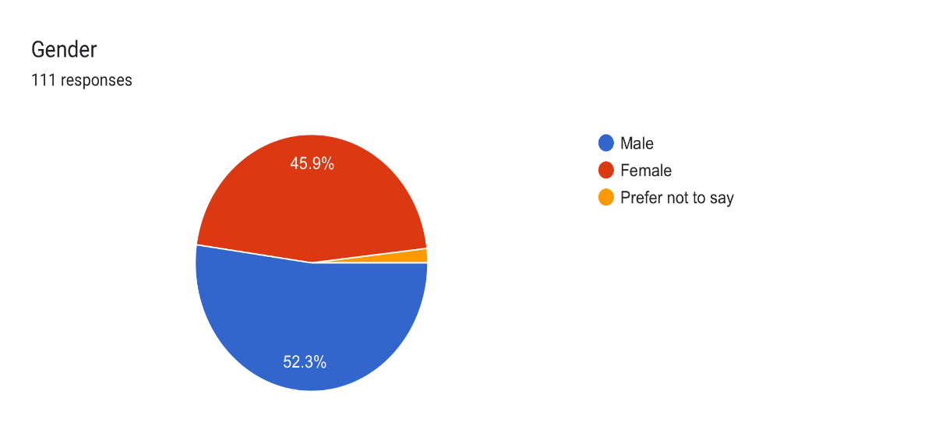

**Fig. 5.1 Gender Classification**

|  |  |  |
| --- | --- | --- |
| SR NO | CATEGORY | NO OF RESPONSES (%) |
| 1 | MALE | 52.3 |
| 2 | FEMALE | 45.9 |
| 3 | PREFER NO TO SAY | 1.2 |
|  | TOTAL | 100 |

**INTERPRETATION:**

After seeing the above pie chart and table we can say that 52.3%respondent are male, 45.9% are female and 1.2% are not comfortable to tell their gender so they selected prefer not to say. Majority of the respondent are Male.

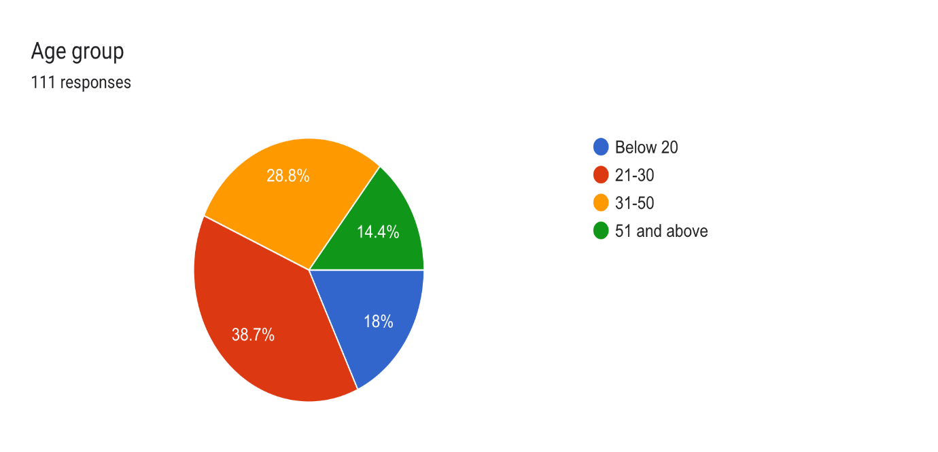3. **Age group**

**Fig 5.2 Age Classification**

|  |  |  |
| --- | --- | --- |
| SRNO | AGE GROUP | NO OF RESPONDENT |
| 1 | BELOW 20 | 18% |
| 2 | 21-30 | 38.7% |
| 3 | 31-50 | 28.8% |
| 4 | 51 AND ABOVE | 14.4% |
|  | TOTAL | 100 |

**INTERPRETATION:**

From the above table and chart, it is observed that among all the respondents 18% are below 20 years of age group, 39% respondents belong to 21-30 years of age group, 28.8% 0f respondents belong to 31-50 years group and only 14.4% belong to 51 and above years of age group.

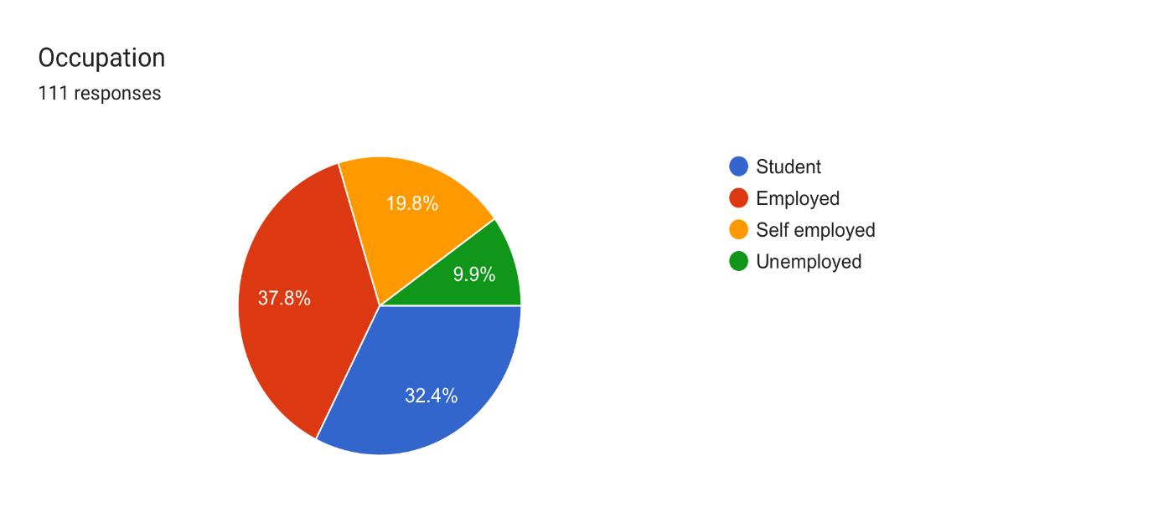4. **Occupation**

|  |  |  |
| --- | --- | --- |
| SR.NO | OCCUPATION | NO OF RESPONDENT |
| 1 | STUDENT | 32.4 |
| 2 | EMPLOYED | 37.4 |
| 3 | SELF - EMPLOYED | 19.8 |
| 4 | UNEMPLOYED | 9.9 |
|  | TOTAL | 100 |

**Fig. 5.3 Occupation Classification**

**INTERPRETATION**

After seeing the above chart and table, it can be drawn that majorly the respondents are employed people and students. 32% of respondents are students. 37% of respondents come under employed service providing group. 20% come under self-employed running their own business and 10% come under unemployed.

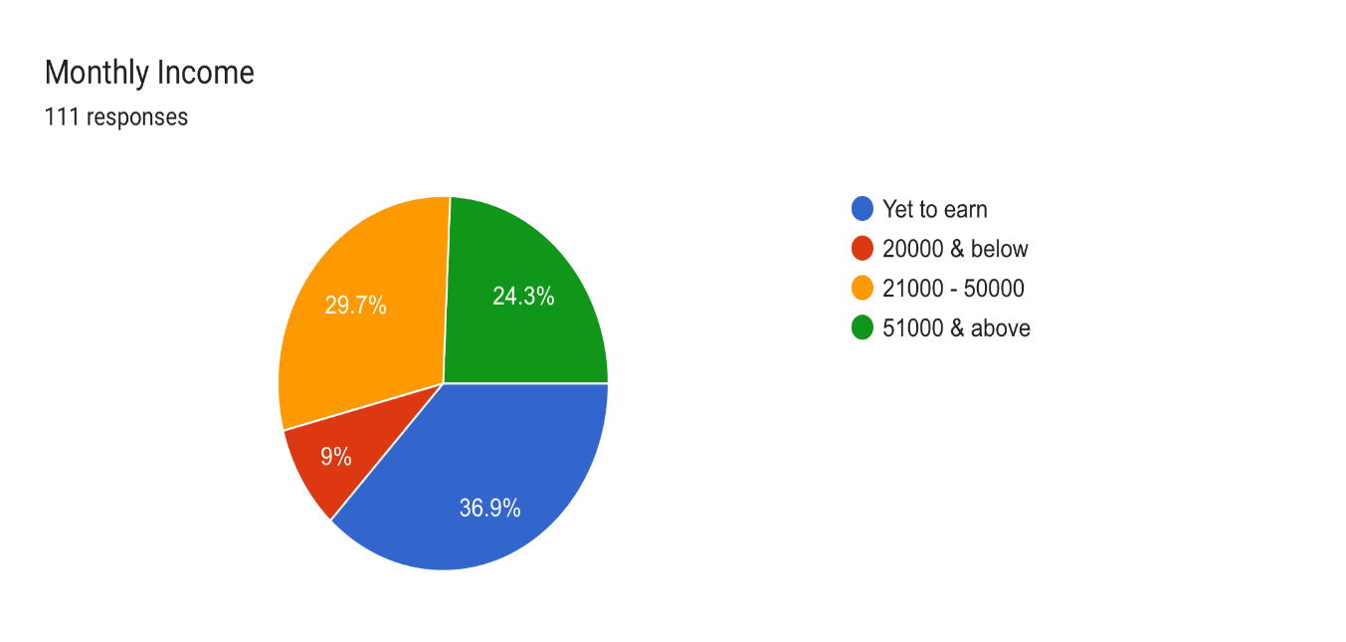5. **Monthly Income**

|  |  |  |
| --- | --- | --- |
| SR.NO | MONTHLY INCOME | NO OF RESPONDENT |
| 1 | YET TO EARN | 36.9% |
| 2 | 20000 & BELOW | 9% |
| 3 | 21000-50000 | 29.7% |
| 4 | 51000 & ABOVE | 24.3% |
|  | TOTAL | 100 |

**Fig. 5.4 Classification of Monthly Income**

**INTERPRETATION:**

As can be seen from the above figure, most respondents are students, therefore it stands to reason that they fall under the yet to earn category, which is represented by 39.6%. Then, while some persons are working and some are self-employed, with a total of 54% responses, their income is between $21,000 and $51,000.

Very few respondents make less than $20,000 annually.

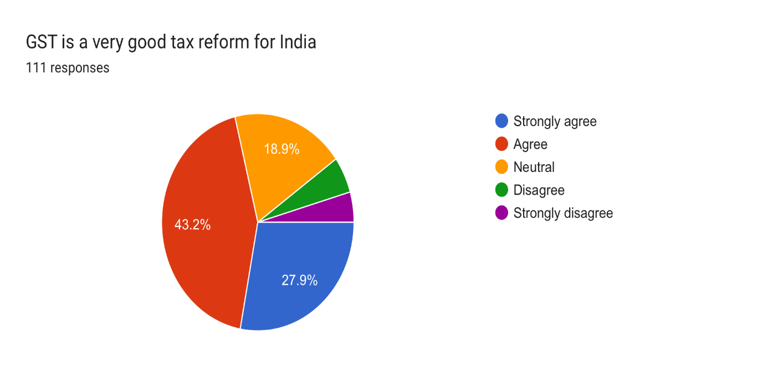6. **GST IS A VERY GOOD TAX REFORM FOR INDIA**

**Fig. 5.5 Tax Reform**

|  |  |  |
| --- | --- | --- |
| SR.NO | OPTIONS | PERCENTAGE% |
| 1 | STRONGLY AGREE | 27.9 |
| 2 | AGREE | 43.2 |
| 3 | NEUTRAL | 18.9 |
| 4 | DISAGREE | 5 |
| 5 | STRONGLY DISAGREE | 5 |
|  | TOTAL | 100 |

**INTERPRETATION:**

In the above table and chart, 28% of all respondents strongly agree and 43% agree that GST is a good tax reform. Neutrality is held by 19% of respondents. In addition, 10% of respondents disagree/strongly disagree that GST is a good tax reform for India.

As a result, most consumers believe that GST is an incredibly good tax reform for India.

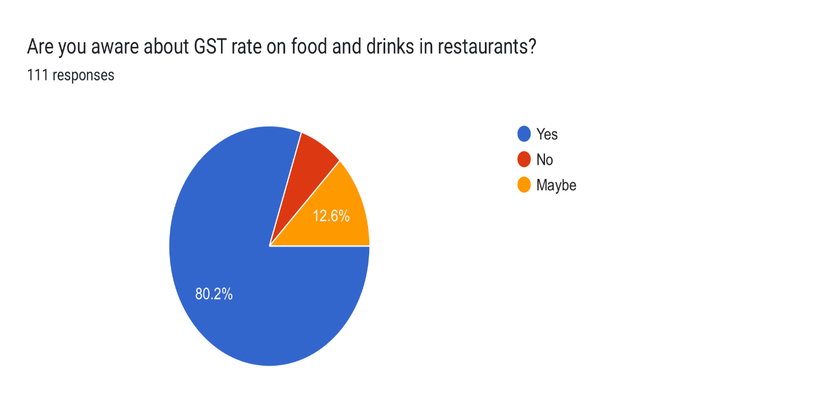7. **Are you aware about GST rate on food and drinks in restaurants?**

|  |  |  |
| --- | --- | --- |
| SR, NO | OPTIONS | PERCENTAGE % |
| 1 | YES | 80 |
| 2 | NO | 7 |
| 3 | MAYBE | 13 |
|  | TOTAL | 100 |

**Fig. 5.6 GST Rate on Food and Drinks**

**INTERPRETATION:**

From the above table and graph, it is observed that out of 100 respondents 80% of respondents are aware of GST charged in restaurant food and drinks, 13% of respondents are not sure about the GST charges in restaurant and 7% of respondents are completely unaware about GST in food and drinks in restaurants.

Majority of consumers are aware about GST in restaurants.

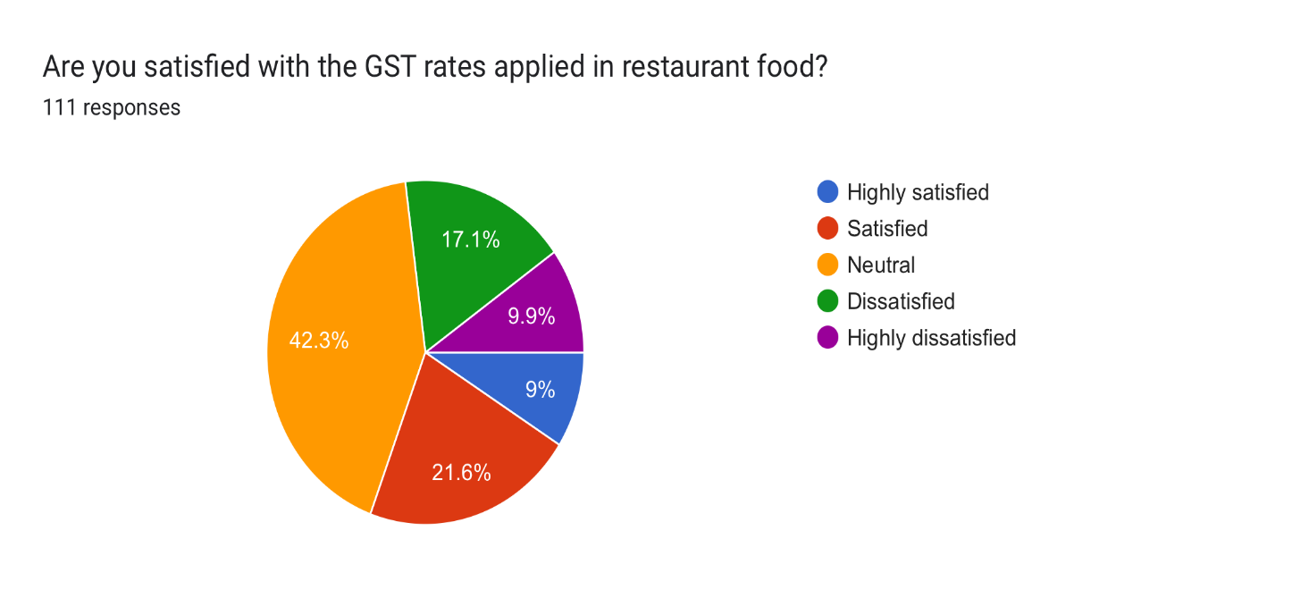**8. Are you satisfied with the GST rates applied in restaurant food?**

**Fig. 5.7 Percentage of Satisfaction**

|  |  |  |
| --- | --- | --- |
| SR.NO | OPTIONS | PERCENTAGE% |
| 1 | HIGHLY SATISFIED | 9 |
| 2 | SATISFIED | 22 |
| 3 | NEUTRAL | 42 |
| 4 | DISSASTISFIED | 17 |
| 5 | HIGHLY DISSASTISFIED | 10 |
|  | TOTAL | 100 |

**INTERPRETATION:**

From the above table and graph, it is observed that among all respondents 9% and 22% of the respondents are satisfied with regards to GST in restaurant. Majority of 42% of the respondents are neither satisfied nor dissatisfied with regards to GST in restaurant. 27% of consumers are dissatisfied with implementation of GST in restaurants.

9. **GST is a good method to replace service tax and VAT?**

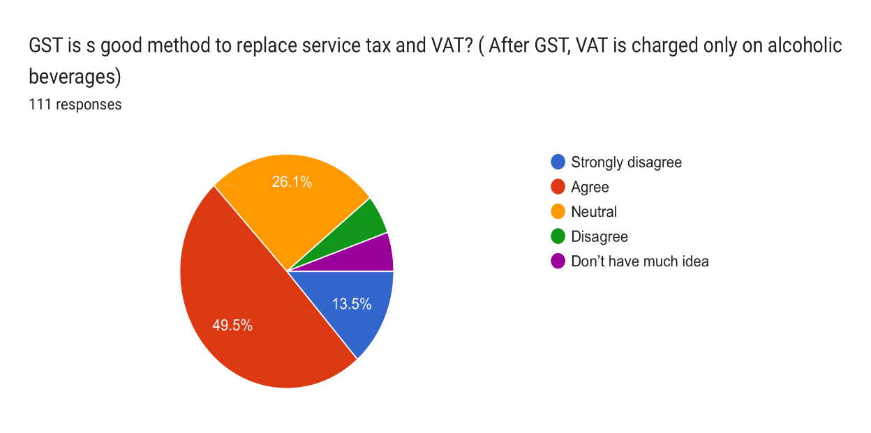

|  |  |  |
| --- | --- | --- |
| SR.NO | OPTIONS | PERCENTAGE% |
| 1 | STRONGLY AGREE | 14 |
| 2 | AGREE | 50 |
| 3 | NEUTRAL | 26 |
| 4 | DISAGREE | 5 |
| 5 | DON’T HAVE MUCH IDEA | 5 |
|  | TOTAL | 100 |

**Fig. 5.8 GST as replacement for service tax and VAT**

**INTERPRETATION:**

From the above table it is observed that 64% of respondents agree with GST being the good method of replacement. 26% of respondents stand neutral. And 5% respondents disagree. 5% of consumers do not have much idea of GST is a good method of replacing service tax and VAT.

Conclusion from the response GST is a good method to replace service tax and VAT.

10. **How often do you prefer eating out in a restaurant or order outside food?**

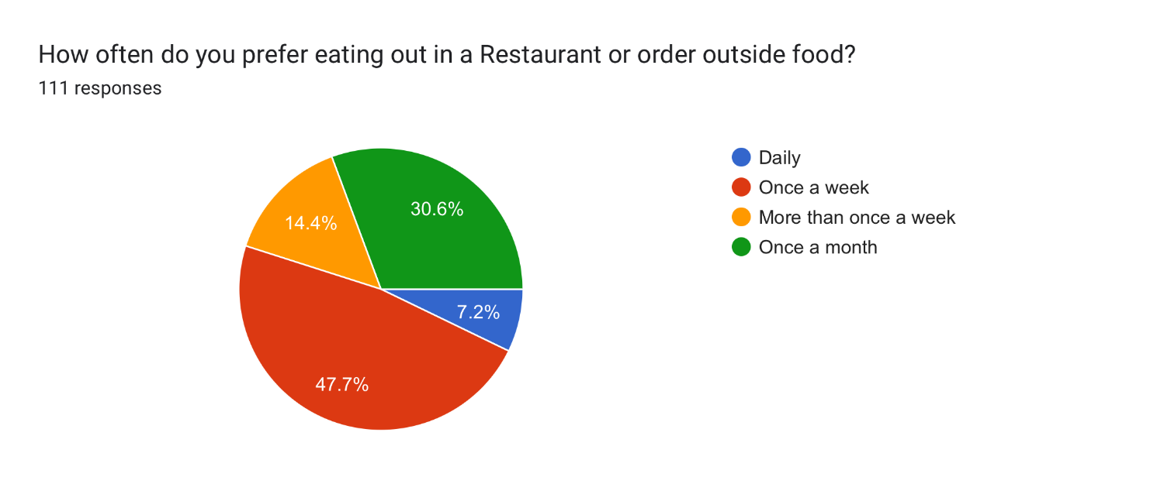

**Fig. 5.9 Eating Habits**

|  |  |  |
| --- | --- | --- |
| SR.NO | OPTIONS | PERCENTAGE% |
| 1 | DAILY | 7 |
| 2 | ONCE A WEEK | 48 |
| 3 | MORE THAN ONCE WEEK | 14 |
| 4 | ONE A MONTH | 31 |
|  | TOTAL | 100 |

**INTERPRETATION:**

According to the above table and graph, most respondents (48%), prefer eating out once a week. Furthermore, 14% prefer eating out more than once a week, while 31% eat out once a month.

Very few respondents eat at restaurants or order takeout on a regular basis.

That means the impact of GST has not changed the consumption of eating restaurant food or order food.

11.**Introduction of GST in India has impacted your restaurant visit?**

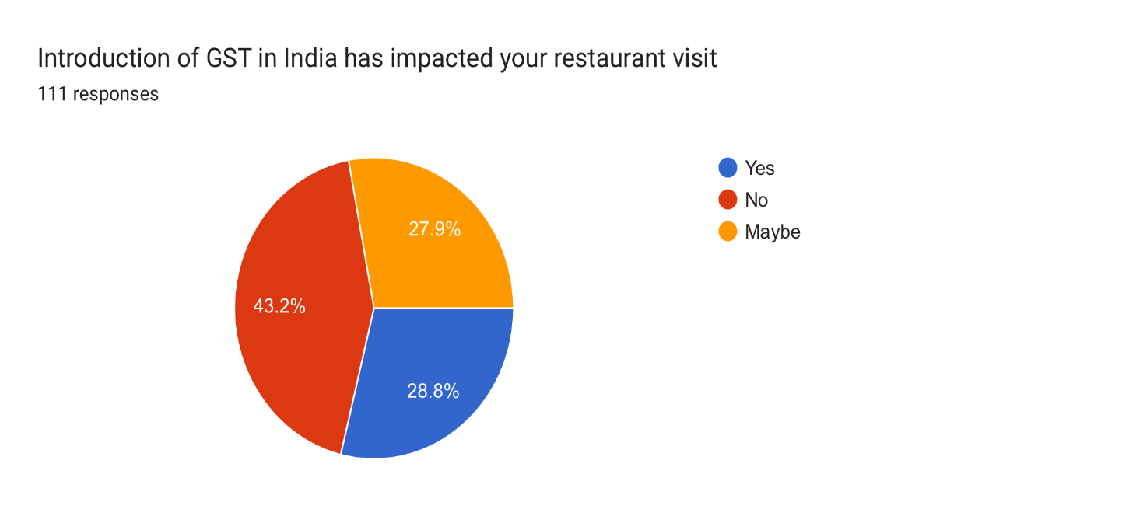

**Fig. 5.10 Impact of GST**

|  |  |  |
| --- | --- | --- |
| SR.NO | OPTIONS | PERCENTAGE% |
| 1 | YES | 30 |
| 2 | NO | 43 |
| 3 | MAYBE | 28 |
|  | TOTAL | 100 |

**INTERPRETATION:**

According to the above table, 30% of the total 100 respondents believe that the implementation of GST has reduced their frequency of restaurant visits, while 28% are unsure. 43% believe that the implementation of GST has had no effect on their frequency of restaurant visits.

As a result, the introduction of GST has some effect on respondents' restaurant visits.

12.**Do you check restaurant bill for tax components?**

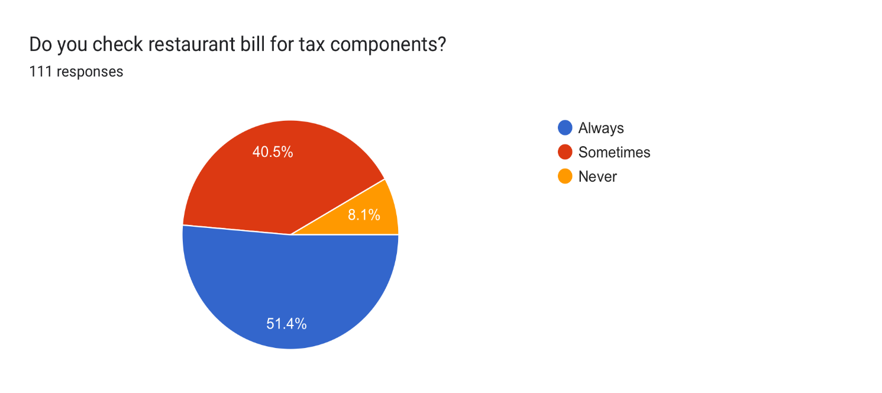

|  |  |  |
| --- | --- | --- |
| SR.NO | OPTIONS | PERCENTAGE% |
| 1 | ALWAYS | 51 |
| 2 | SOMETIMES | 41 |
| 3 | NEVER | 8 |
|  | TOTAL | 100 |

**Fig. 5.11 Awareness of Tax Components**

**INTERPRETATION:**

Based on the above table and graph, most survey respondents check the restaurant bill for tax component before mailing the payment, while only 8% don't really check the bill for tax component.

13 **Have you observed any changes in the menu or offering of restaurants since the implementation of GST?**

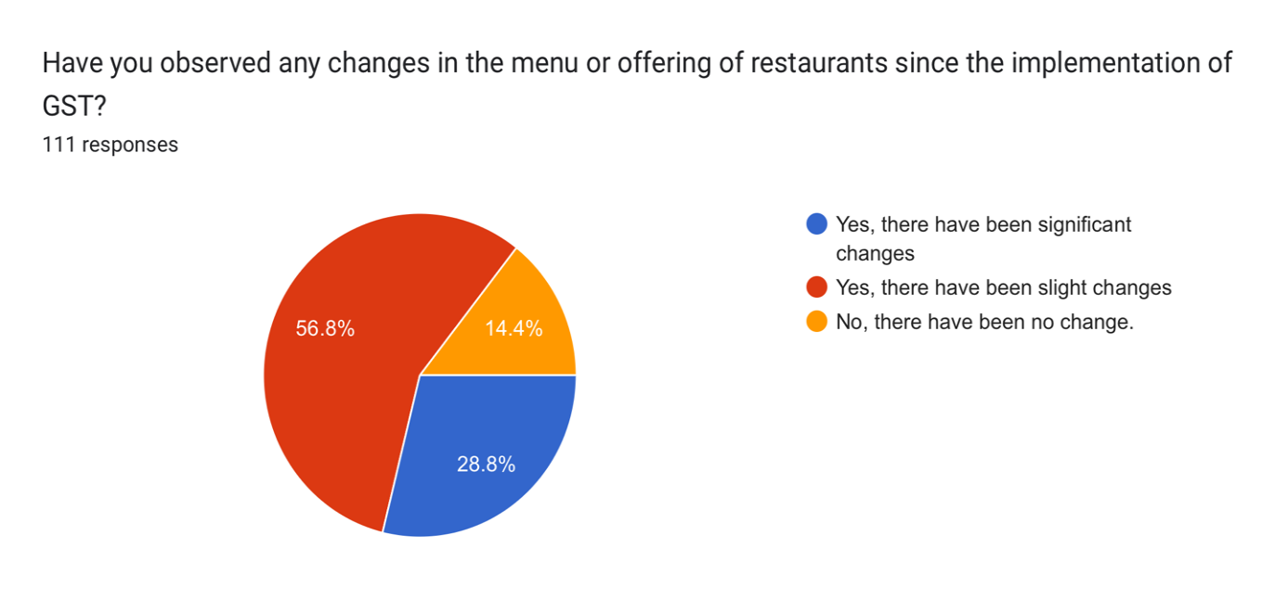

**Fig. 5.12 Changes Post GST in menu**

|  |  |  |
| --- | --- | --- |
| SR.NO | OPTIONS | PERCENTAGE% |
| 1 | YES, THERE HAVE BEEN SIGNIFICANT CHANGES | 29 |
| 2 | YES, THERE HAVE SLIGHT CHANGES | 57 |
| 3 | NO, THERE HAVE BEEN NO CHANGES | 14 |
|  | TOTAL | 100 |

**INTERPRETATION:**

In accordance with the above table and graph, 57% of respondents observed minor changes in the restaurant menu, while 29% observed significant changes in the restaurant menu. 14% of respondents are unaware of any changes made in the restaurant menu.

|  |  |  |
| --- | --- | --- |
| SR.NO | OPTIONS | PERCENTAGES% |
| 1 | YES, I THINK IT IS POSITIVE STEP TOWARDS TAX REFORM | 47 |
| 2 | NO, I DO NOT THINK IT IS A POSITIVE STEP TOWARDS TAX REFORM | 19 |
| 3 | I AM NOT SURE | 32 |
|  | TOTAL | 100 |

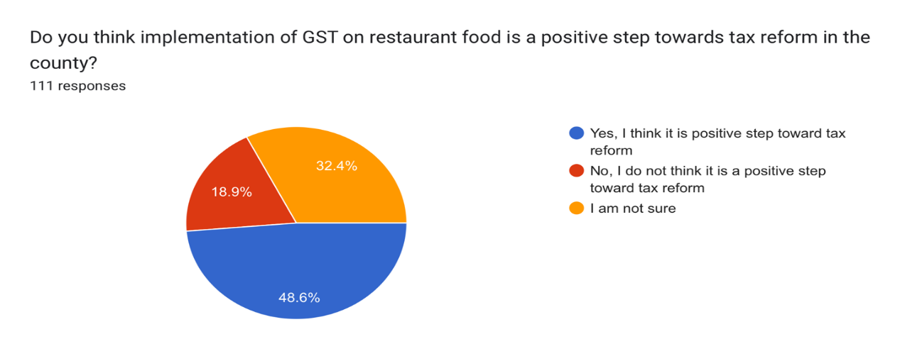14. **Do you think implementation of GST on restaurant food is a positive step towards tax reform in the county?**

**Fig 5.13 Result of GST**

**INTERPRETATION:**

According to the table and graph above, 47% of respondents believe that the GST is a positive step towards tax reform for the Indian economy. 19% disagree and do not believe it is a positive step towards tax reform, while 32% are unsure and are unaware of the tax reform.

15.**Have you noticed any changes in the quality of food or service since the implementation of GST?**

|  |  |  |
| --- | --- | --- |
| SR.NO | OPTIONS | PERCENTAGE% |
| 1 | YES, THE QUALITY HAS IMPROVED | 12 |
| 2 | NO, THE QUALITY HAS REMAINED THE SAME | 82 |
| 3 | NO, THE QUALITY HAS DECLINED | 6 |
|  | TOTAL | 100 |

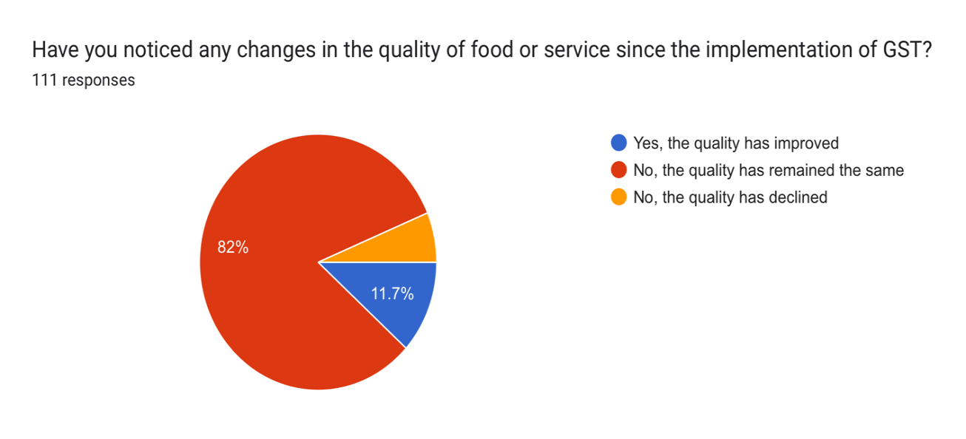

**Fig 5.14 Changes in the quality of food or services**

**INTERPRETATION:**

In accordance with the table and graph, 82% of respondents have observed no change in the quality of food and services since the implementation of GST. 12% believe there has been a quality improvement in food and services. Few respondents believe that the quality of food and services has deteriorated.

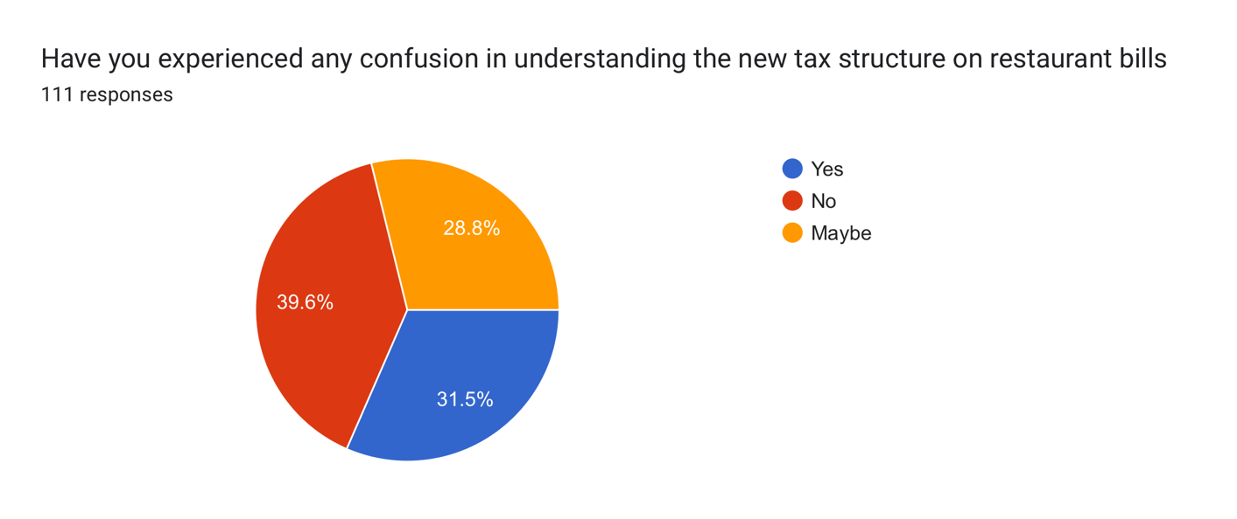16. **Have you experienced any confusion in understanding the new tax structure on restaurant bills**

**Fig. 5.15 Understanding New Tax Structure**

|  |  |  |
| --- | --- | --- |
| SR.NO | OPTIONS | PERCENTAGE |
| 1 | YES | 31 |
| 2 | NO | 40 |
| 3 | MAYBE | 29 |
|  | TOTAL | 100 |

**INTERPRETATION:**

According to the data in the table, 31% of respondents are puzzled by the new tax structure on restaurant bills. 40% are not confused and are aware of the new tax structure on restaurant bills. 29% are unsure about the new tax structure that applies to restaurant bills.

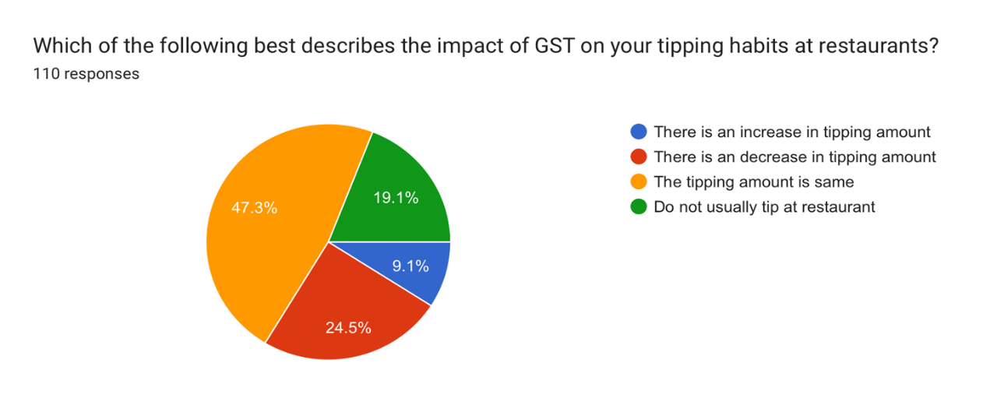17. **Which of the following best describes the impact of GST on your tipping habits at a restaurant?**

|  |  |  |
| --- | --- | --- |
| SR.NO | OPTIONS | PERCENTAGE% |
| 1 | THERE IS AN INCREASE IN TIPPING AMOUNT | 9 |
| 2 | THERE IS AN DECREASE IN TIPPING AMOUNT | 25 |
| 3 | THE TIPPING AMOUNT IS SAME | 47 |
| 4 | DO NOT USUALLY TIP AT RESTUARANT | 19 |
|  | TOTAL | 100 |

**Fig. 5.16 Tipping Habits**

**INTERPRETATION:**

According to the data presented above, 25% of respondents increased their tipping amount following the implementation of GST. 47% have not changed their tipping habits and have remained consistent. Even before the implementation of GST, 19% of respondents did not usually tip at a restaurant. After the implementation of GST, only 9% of respondents increased their tipping amount.

As a result, we can conclude that the consumer's tipping habits have changed to some extent as a result of the implementation of GST.

**5.1 FINDING OF THE STUDY**

From the above data analysis and interpretation, following are the finding of the study.

* Majority of the respondents are from the male category i.e.., 52.3%
* Most of the respondents falls in the age group of 21-30 i.e., 38.7%
* Most of the respondents i.e.., 32.4% are student and 37.5% are organisation employees.
* 36.9 % respondents fall under yet to earning income group since most respondents are students.
* Majority of respondents i.e.., 43.2% agreed to the statement GST being a very good tax reform for India.
* Among all the respondents, majority of 80% respondents are aware about the GST rate on food and drinks in restaurants.
* 42% of respondents have chosen to remain neutral about satisfaction with GST rates applied in restaurant food.
* Among all the respondents, majority of 50% respondents have agree to the statement of GST being a good method to replace service tax and VAT.
* The study revealed that 48% of respondents prefer eating out in a restaurant or order food once a week.
* 43% have not changed their restaurant visit habits since the implementation of  GST, while 30% have.
* Majority of 51% check the restaurant bill for tax component and 41% sometimes check the bill for tax component.
* Among all the respondents 57% have seen slight changes in the menu and offering of restaurant since the implementation of GST
* 47% of respondents have agreed to the statement of GST on restaurant food is a positive step towards tax reform in the country.
* Majority of 82% of respondents have seen no quality change in food and services and has remained the same since the implementation of GST.
* 40% of respondents have no confusion in understanding the new tax structure on restaurant bill while 31% still have confusion regarding the tax structure.
* Among all the respondents 47% have chosen to keep the tipping amount same even after the impact of GST on restaurant food.

**5.2 SUGGESTION**

The Goods and Services Tax (GST) implementation in the restaurant industry has had a major impact on Mumbai's food consumers. GST is an integrated tax system that has replaced multiple indirect taxes such as service tax and value-added tax, making the tax system simpler and more transparent. While there was some general confusion and misunderstanding, GST has resulted in several positive changes.

The standardisation of taxes has been one of the most significant effects of GST. Previously, different states' tax rates made it difficult for consumers to compare prices and make informed decisions. With the implementation of GST, however, the tax rate has been standardised across India, making it easier for consumers to understand and compare restaurant food prices across the country. The standardised tax system has also made it easier for restaurant owners to comply with tax laws, lowering the cost of doing business and potentially leading to lower consumer prices.

One of the most significant effects of GST has been the standardisation of taxes. Previously, consumers found it difficult to compare prices and make informed decisions due to the disparities in tax rates between states. The implementation of GST, on the other hand, has standardised the tax rate across India, making it easier for consumers to understand and compare restaurant food prices across the country. The standardised tax system has also made it easier for restaurant owners to comply with tax laws, potentially lowering consumer prices.

Although GST has slightly increased prices, consumers can now see the exact amount of taxes they are paying, resulting in greater price transparency. Previously, some restaurants added service tax and VAT separately, which frequently caused confusion and disputes. With GST, however, consumers can now see the GST amount charged on their bills, alerting them to the taxes they are paying. Greater pricing transparency has enabled consumers to make more informed decisions when dining out.

While some customers are still suspicious of the new tax system, the great majority have adjusted, and GST has become an accepted part of the dining experience in Mumbai. Overall, GST has benefited Mumbai food consumers by increasing transparency, standardisation, and compliance in the restaurant industry.

**5.3 CONCLUSION**

Consumers can take several steps to understand and manage the impact of GST on restaurant food. Firstly, consumers can educate themselves about the new tax system and understand the components of their restaurant bills. Additionally, consumers can research and compare prices of different restaurants to ensure that they are getting value for their money.

Secondly, consumers can provide feedback to restaurants regarding their pricing strategy and the impact of GST on their dining experience. This can include expressing their views on menu prices, the inclusion of taxes in the bill, and the overall dining experience. By providing feedback, consumers can influence restaurants to adopt more transparent and consumer-friendly pricing strategies.

Lastly, consumers can be mindful of their dining choices and opt for restaurants that are compliant with GST regulations. This can help to encourage compliance among restaurants and ensure that consumers receive a trustworthy and reliable dining experience.

In summary, consumers can take steps to understand and manage the impact of GST on restaurant food by educating themselves, providing feedback, and being mindful of their dining choices. By doing so, consumers can help to establish a more transparent and efficient taxation system for the restaurant industry.

**ANNEXURE**

**IMPACT OF GST ON FOOD CONSUMERS IN THE RESTAURANT WITHIN THE MUMBAI CITY.**

1. Name
2. Gender

* Male
* Female
* Prefer not to say.

1. Age group

* Below 20
* 21-30
* 31-50
* 51and above

1. Occupation

* Student
* Employee
* Self-employed.
* Unemployed

1. Monthly Income

* Yet to earn
* 20000 & below
* 21000 -50000
* 51000 & above

1. GST is a very good tax reform in India?

* Strongly agree.
* Agree
* Neutral
* Disagree
* Strongly disagree.

1. Are you aware about GST rate on food and drinks in restaurants?

* Yes
* No
* Maybe

1. Are you satisfied with the GST rates applied in restaurant food?

* Highly satisfied
* Satisfied
* Neutral
* Dissatisfied
* Highly dissatisfied

1. GST is a good method to replace service tax and VAT?

* strongly agree.
* Agree
* neutral
* disagree
* strongly disagree.
* Don’t have much idea.

Note: After introduction of GST VAT is charged only on alcoholic beverages

1. How often do you prefer eating out in a restaurant or order outside food?

* Daily
* Once a week
* More than once a week
* Once a month

1. Introduction of GST in India has impacted your restaurant visit.

* Yes
* No
* Maybe

1. Do you check the restaurant bill for tax component?

* Always
* Sometimes
* Never

1. Have you observed any changes in the menu or offerings of restaurants since the implementation of GST?

* Yes, there have been significant changes.
* Yes, there have been slight changes.
* No, there have been no changes.

1. Do you think the implementation of GST on restaurant food is a positive step towards tax reform in the country?

* Yes, I think it is a positive step towards tax reform.
* No, I do not think it is a positive step towards tax reform.
* I am not sure.

1. Have you noticed any changes in the quality of food or service since the implementation of GST?

* Yes, the quality has improved.
* No, the quality has remained the same.
* No, the quality has declined.

1. Have you experienced any confusion in understanding the new tax structure on restaurant bills?

* Yes, I have experienced confusion.
* No, I have not experienced confusion.

1. Which of the following best describes the impact of GST on your tipping habits at restaurants?

* There is an increased in tipping amount.
* There is a decrease in tipping amount.
* The tipping amount is same.
* Do not usually tip at restaurants.

**WEBLIOGRAPHY**

ONLINE REFERENCE

<https://cleartax.in/s/impact-gst-food-services-restaurant-business>

<https://groww.in/p/tax/gst-on-food-and-restaurants>

<https://www.taxgyata.com/ap/gst-on-restaurant-services/>

<https://www.cagmc.com/gst-on-restaurant-services-normal-scheme-or-composition-scheme/>

<https://vakilsearch.com/blog/gst-registration-limit-for-restaurants/>

<https://www.bankbazaar.com/tax/types-of-gst.html>

<https://markitsolutions.in/impact-of-gst-on-restaurants/>

<https://www.ijmra.us/project%20doc/2019/IJMIE_MARCH2019/IJMRA-15230.pdf>

<https://cleartax.in/s/impact-gst-food-services-restaurant-business>

<https://www.ijmra.us/project%20doc/2019/IJMIE_MARCH2019/IJMRA-15230.pdf>

<https://www.voolsy.com/updates/blog/overview-impact-gst-restaurant-industry/amp/>

<https://ijtrs.com/uploaded_paper/THE%20IMPACT%20OF%20GST%20(GOODS%20AND%20SERVICE%20TAX)%20IN%20INDIA-A%20SPECIAL%20REFERENCE%20TO%20RESTAURANTS%20BUSINESS%20IN%20INDIA.pdf>

<https://www.jetir.org/papers/JETIRCF06011.pdf>

<https://www.researchgate.net/publication/334162539_Impact_of_Goods_and_Services_Tax_on_the_Restaurants_and_Food_Service_Businesses_in_India>